Navigating the Transition to College: LGBTQ+ Students’ High School Experiences and Academic Plans

Authors: Christina Sun, Alexandria Hurtt, and Michal Kurlaender

Abstract
Limited research considers the diversity of experience across gender identity and sexual orientation during the transition from high school to college. Drawing on the results of a large-scale survey of California high school seniors, we examine LGBTQ+ students’ high school experiences and college expectations, including their concerns about college prior to matriculation. Findings reveal there is a statistically significant difference between the high school experiences of cisgender heterosexual students and LGBTQ+ students, who, on average, report less positive experiences and substantially higher rates of identity-based bullying. Moreover, LGBTQ+ students maintained higher levels of worry about discrimination compared to their counterparts, with binary-identifying transgender students more likely to report discrimination concerns compared to nonbinary and other gender diverse students. Despite heightened concerns about discrimination, LGBTQ+ students maintained elevated educational aspirations, including higher rates of planned four-year enrollment and advanced degree pursuit. These results carry implications for California education policy, including the need for targeted anti-bullying interventions and the continued collection and disaggregation of data by gender identity and sexual orientation.
Acknowledgements
The data used in this research was collected through a partnership between the California Education Lab and the California Student Aid Commission. The authors are grateful for ongoing grant support from the College Futures Foundation and the Stuart Foundation. The findings and conclusions here are those of the authors alone and do not necessarily reflect the positions or policies of the funders or of the California Student Aid Commission. The authors thank Kairo Weber, Baiyu Zhou, Elizabeth Friedmann, Sherrie Reed, Paco Martorell, Scott Carrell, Maria Charles, and Laurel Westbrook for their expertise and support in the construction of the survey, analysis, and/or review of findings. We also thank Kerith Jane Conron for helpful feedback on an earlier draft of the paper.

Introduction
A critical choice students make is whether to pursue a postsecondary education. This choice is shaped by students’ experiences in high school (Kurlaender et al., 2019; Reed et al., 2023; Uwah et al., 2008), which can influence their educational aspirations and expectations (Bergerson, 2009)—important predictors of later educational attainment (Jacob & Wilder, 2010; Sewell et al., 1969). Moreover, research has long documented differences in aspirations and expectations across student groups (Bergerson, 2009), including race/ethnicity, gender, and first-generation status (Kao & Tienda, 1998; Mau & Bikos, 2000; McCarron & Inkelas, 2006; Solorzano, 1992; Trusty, 2002), with recent studies drawing on more expansive definitions of gender identity and sexual orientation (Aragon et al., 2014; Feldman et al., 2022).
Despite this, gaps are still present in research examining the educational aspirations of different gender and sexual identities, including intended field of study in college. Given that lesbian, gay, bisexual, transgender, and queer (and/or questioning) (LGBTQ+) students are distinct groups (e.g., Beemyn, 2022; Watson et al., 2020), each of which likely experience school and the college-going process differently, it is important to interrogate the extent to which college aspirations and expectations differ by gender identity and sexual orientation. Moreover, LGBTQ+ students frequently report experiencing harassment and discrimination in high school, often related to their sexual orientation, gender identity, and/or how they express their gender (Kosciw et al., 2022). This may impact their specific academic aspirations and broader considerations about college, as school victimization can lead to lower levels of school belonging and self-esteem, high rates of absenteeism, and diminished academic outcomes, including college enrollment (Aragon et al., 2014; Heck et al., 2014; Sansone, 2019). How differences in LGBTQ+ students’ secondary experiences may affect their educational trajectories is also important to examine, particularly as federal protections for these students have been rolled back amidst the current federal landscape (Schultz, 2025). This paper thus aims to examine associations between gender and sexual identities, academic aspirations, and college concerns among a recent cohort of college-bound 12th graders in California. In addition, we evaluate whether differences in students’ aspirations and expectations may be attributable, at least in part, to differences in high school experiences, including whether a student faced harassment or bullying.
This study explores the following research questions: (1) Do students’ college aspirations and expectations differ by gender identity and sexual orientation? and (2) If so, to what extent are these observed differences attributable to students’ high school experiences? Drawing on the results of a large-scale survey conducted in partnership with the state agency responsible for administering financial aid in California, we explore patterns in high school experiences and college expectations to investigate what LGBTQ+ students consider ahead of the college transition. In this case, we specifically highlight subgroups of the LGBTQ+ community in effort to analyze potential inequalities students may experience and how this might influence the college transition process. Additionally, this study focuses on California students given the state’s broad diversity across demographics, geography, and postsecondary opportunities. Moreover, as the state has historically adopted more protective policies for LGBTQ+ students compared to other states (e.g., the FAIR Education Act, comprehensive anti-discrimination protections), California is a particularly important context for this analysis.

Defining Gender Identity and Sexual Orientation
Students use a variety of labels to describe both their gender identity and sexual orientation (Callis, 2014; Galupo et al., 2015), reflecting the fact that traditional binary labels (e.g., woman, man, heterosexual, homosexual) are often constraining descriptors for the complex ways individuals experience gender and sexuality (Hammack et al., 2022; Morgan, 2013). Research suggests students are constructing their own identities through different labels (Watson et al., 2020; White et al., 2018); although individuals continue to identify with traditional binary labels, many students now use a more expansive set of labels for both gender (e.g., nonbinary, genderfluid) and sexual orientation (e.g., asexual, queer) (Beemyn, 2022; Hammack et al., 2022). Additionally, not every individual may feel comfortable selecting a label, or may be unsure about which labels to select, with questioning and unsure commonly reported terms for both gender identity and sexual orientation (Watson et al., 2020; White et al., 2018). In this study, we utilize a novel dataset that acknowledges the spectrum of labels students may use to define their identities outside a binary construct and spotlight LGBTQ+ students in our analysis to enrich understanding of their unique experiences navigating the high school to college transition.
This study is organized as follows: We first review prior literature and the theoretical frameworks guiding our analysis. Next, we describe our data sources, key measures, and analytic approach, followed by our findings. We then discuss limitations before considering implications for policy and practice.

Theoretical Background and Prior Literature
The transition from high school to college is shaped by a confluence of individual and institutional factors that can affect students’ educational expectations and later attainment (Kurlaender et al., 2019). Individual differences, relationships, the school one attends, and one’s broader context all play a role during this critical period (Luh et al., 2023; Pike & Robbins, 2016). At the student level, attributes such as motivation, self-efficacy, and academic performance moderate students’ educational trajectory (Bandura, 1981; Casillas et al., 2012; Lazowski & Hulleman, 2016). Moreover, high school academic performance is associated with one’s aspirations to both two- and four-year colleges (DesJardins et al., 2019), suggesting that students’ perceptions of their chances of admission and success also guide their postsecondary plans.
Additionally, various forms of social and cultural capital play a role in shaping students’ educational pathways (Bourdieu, 1986; Dumais & Ward, 2010; Merolla & Jackson, 2014; Plagens, 2011; Wells, 2008). For example, social capital (the resources available through one’s social networks) shapes college-going outcomes; research indicates that relationships with peers, family members, and mentors can support students’ acquisition of valuable information about the college application and enrollment process and help develop stronger college-going attitudes and behaviors (Alvarado & An, 2015; Hill, 2008; Morton et al., 2018; Perna, 2000; Skobba et al., 2018). Moreover, students that can navigate the socially constructed norms surrounding the college process, and whose networks provide access to academic and social resources for this transition, are more likely to enroll in college (Choi et al., 2008; Fletcher, 2015). As LGBTQ+ students often experience hostile social environments in schools and at home, caring adults and social support more broadly may be particularly important to the college-going process. Beyond social capital, research suggests LGBTQ+ students living in cis-normative environments exhibit particular strengths, possessing several types of queer cultural capital (Pennell, 2016). This includes navigational capital, or the ability to navigate schools and other institutional systems that are not always designed with LGBTQ+ students in mind. In this case, students must learn to navigate cis-normative school systems and spaces (e.g., state policies about gendered restrooms, sports participation, or social activities), potentially in creative ways, in order to access the psychological, social, cultural, and physical resources they need for their well-being (Pennell, 2016).
At the institutional level, schools shape students’ expectations of college and future educational attainment through the environments they cultivate (Eccles & Roeser, 2011; Uwah et al., 2008). A school culture characterized by high values and expectations for learning is associated with increased academic outcomes (Hattie, 2009), and school safety and climate are also critical to engagement, belongingness, and achievement (Osterman, 2000; Walton & Cohen, 2011). As schools may be unsafe learning environments for LGBTQ+ students, who often experience higher rates of bias-based bullying and victimization (Day et al., 2018), LGBTQ+ students’ perception of school climates may be inherently different from those of their cisgender heterosexual peers. Moreover, students’ schooling experiences are mediated by stressors that underlie societal conditions, including external (e.g., discrimination and violence) and internal stressors (e.g., expectations of prejudice, concealment, internalized stigmas). These stressors, heightened for LGBTQ+ students, can affect psycho-social outcomes (Hunter et al., 2021), ultimately influencing educational expectations and the transition from high school to college more broadly. For example, prior research indicates that transgender youth often experience gender-related victimization, particularly in secondary schools, which may lead to higher levels of emotional distress and lower levels of school belonging (McBride, 2021). Moreover, victimization, reduced feelings of school belonging, and emotional distress can have a negative effect on school attendance, academic performance, and expectations to enroll in a four-year college for all LGBTQ+ youth (Aragon et al., 2014). Altogether, research suggests students’ high school experiences influence their future educational behavior (Gong & Toutkoushian, 2024).
Our work is thus motivated by several frameworks to understand how LGBTQ+ students navigate the transition from high school to college. First, we draw on a newer model of college choice (Klasik et al., 2025) that builds upon prior models (e.g., Hossler & Gallagher, 1987; Perna, 2006) to include expectations as a critical component in students’ predisposition for college. We examine the ways in which high school experiences influence students’ college expectations (including academic plans, concerns, and excitements) in the spring of their senior year and focus on an understudied and marginalized group: LGBTQ+ students.
As college expectations are context-dependent, this work is also framed by the social ecological theory of resilience (Ungar, 2011, 2012) to understand the potential variation in the college expectations of LGBTQ+ students, who must often navigate hostile environments and cis-normative policies and norms at school and within society more generally (Kosciw et al., 2022). LGBTQ+ youth that faced harassment or social exclusion in high school may look towards college as a new opportunity to fit in, while those who did not struggle as much may have other concerns. Similarly, LGBTQ+ students that plan to live away from home while in college may feel increased trepidation (i.e., leaving familial support) or, in contrast, relief (i.e., escaping familial discomfort or hostility) (O’Neill & Conron et al., 2022). As college transitions vary across demographic differences, including gender (Means et al., 2016; Toutkoushian et al., 2018), students’ identities concurrently influence their lived experiences and expectations for their pathway to college (Feldman et al., 2022; Fotopoulou, 2012). Therefore, it is important to consider different elements of students’ identities in addition to how those identities are shaped by students’ networks and environment. As such, the differences we observe in LGBTQ+ students’ expectations for college will reflect students’ experiences and the ways in which they navigate their own situated context.

Data and Methods

Survey Instrument and Sample Characteristics
In May 2023, in partnership with the California Student Aid Commission (CSAC)—the state agency responsible for administering financial aid programs for students attending public and private universities, colleges, and vocational postsecondary institutions in California—we administered a web-based survey to document the experiences of high school seniors planning to enroll in college. The survey was distributed to all seniors statewide that submitted either the Free Application for Federal Student Aid (FAFSA) or for undocumented students, the California Dream Act Application (CADAA) for the 2023-24 academic year. A total of 323,555 students were sent an invitation to participate in the survey through CSAC; 10,221 completed surveys, including 9,230 respondents who indicated they planned to go to college, 170 who did not plan to attend, 294 that were unsure, and 527 who did not respond about their enrollment plans. Our response rate was 3.2%, which is low but not unexpected with census level surveys of young adults. Students reported on varying dimensions of their high school experiences; the support they received in preparation for college; their academic interests and plans for postsecondary enrollment; and their concerns about college. Detailed information on gender identity and sexual orientation was also collected. After excluding respondents who were missing information about gender identity (n = 1,708), sexual orientation (n = 1,749), race/ethnicity (n = 1,617), or parental education (n = 1,647), our final analytic sample included 7,522 participants (Table 1).
Compared to California’s 12th grade enrollment in 2022-23 (see Appendix Table A2), our sample is broadly, though imperfectly, representative of the state’s college-bound senior population. In terms of race and ethnicity, our sample mirrors statewide enrollment, though Hispanic/Latinx students are modestly underrepresented (49.8% vs. 55.7% statewide), while Black/African American and Asian students are slightly overrepresented (7.0% vs. 4.9% and 15.1% vs. 9.5%, respectively). A direct comparison of gender is difficult to draw given that the state reports enrollment using only male, female, and nonbinary categories. With that caveat in mind, our sample skews more female than the statewide enrollment figures would suggest (57.0% cisgender women vs. 48.2% female statewide).

Table 1. Demographic Characteristics of 12th Grade Survey Participants
 | n | Percent
Panel A. Gender identity
Cisgender man | 2,675 | 35.6
Cisgender woman | 4,289 | 57.0
Transgender man | 59 | 0.8
Transgender woman | 20 | 0.3
Nonbinary | 267 | 3.6
Gender diverse/questioning | 71 | 0.9
Prefer not to say | 141 | 1.8
Total reported gender identity | 7,522 | 100.0
Panel B. Sexual orientation
Straight/heterosexual | 5,190 | 69.4
Gay or lesbian | 330 | 4.4
Bisexual/pansexual/omnisexual | 1,139 | 15.2
Asexual/aromantic/demisexual | 182 | 2.4
Other/queer/questioning | 131 | 1.8
Prefer not to say | 509 | 6.8
Total reported sexual orientation | 7,481 | 100.0
Panel C. Race/ethnicity
American Indian/Alaskan Native | 163 | 2.1
Black/African American | 532 | 7.0
Hispanic/Latinx | 3,793 | 49.8
Pacific Islander | 64 | 0.8
Filipino | 235 | 3.1
Asian | 1,146 | 15.1
Other | 182 | 2.4
White/non-Hispanic | 1,498 | 19.7
Total reported race/ethnicity | 7,613 | 100.0
Panel D. Highest level of education among parents
Did not complete high school | 1,373 | 18.1
High school diploma | 1,578 | 20.8
Some college, no college degree | 975 | 12.9
Associate degree | 452 | 6.0
Bachelor’s degree | 1,363 | 17.9
Graduate/professional degree | 1,455 | 19.2
Don’t know | 387 | 5.1
Total reported parental education | 7,583 | 100.0

To collect data on gender identity, we adopted the two-step approach recommended by the GenIUSS group given its high sensitivity and specificity in accurately discriminating between transgender and cisgender respondents (Herman, 2014; Saperstein & Westbrook, 2021). This approach includes two questions: (1) What is your sex assigned at birth, on your original birth certificate?, with male and female as response options; and (2) What is your current gender identity?, with woman, man, nonbinary, prefer not to say, and other as response options. Respondents who chose other also had the option to write in a response. Using these survey items, we classify respondents into one of the following umbrella categories: cisgender, transgender and gender expansive (Robinson & Cooper, 2024), and prefer not to say. Respondents who reported that their sex assigned at birth aligned with their current gender identity (e.g., male and man; female and woman) were categorized as cisgender, while respondents who reported their sex assigned at birth differed from their current gender identity were categorized as trans(gender) and gender expansive. The Human Rights Campaign uses the term trans(gender) and gender expansive to describe “the collective community of individuals whose gender identities, gender presentations and expressions, and/or lived experiences differ from those typically associated with the sex they were assigned at birth” (Robinson & Cooper, 2024). Here, we adopt this collective umbrella term to refer to all respondents who identified differently than their sex assigned at birth while recognizing that “trans” and “gender expansive” are not necessarily distinct or mutually exclusive identities, and that some may not use these labels to describe their personal identity.
We further classify trans and gender expansive students into the following sub-categories, which we utilize in our analysis: transgender men, transgender women, nonbinary, and gender diverse/questioning. For example, students who reported their sex assigned at birth as female or male and who identified as a man or a woman were categorized as binary-identifying transgender men and women, respectively. Students who selected nonbinary or wrote in responses that included the term “nonbinary” were categorized as nonbinary regardless of sex assigned at birth. Students who wrote in other diverse gender identities (e.g., genderfluid) are captured by the term gender diverse/questioning. Our analysis revealed some significant differences between the experiences of nonbinary and gender diverse/questioning students, which provides additional support for these distinctions. Finally, students who chose prefer not to say or wrote in malicious responses (e.g., racial and gender slurs) were classified as prefer not to say. Among the trans and gender expansive students in our sample (n = 417), about 19% identified as transgender, 64% as nonbinary, and 17% as gender diverse/questioning. Beyond predefined options, students also noted 26 unique terms to describe their gender identity, including genderfluid, agender, genderqueer, and two-spirit, among many others. We also examined associations between gender identity and sexual orientation and found that trans and gender expansive students were more likely to select a non-heterosexual sexual orientation than cisgender students (see Table A1 in Appendix A).
To measure sexual orientation, we adapted the survey instrument recommended by the Sexual Minority Assessment Research Team (SMART) to capture the breadth of students’ identities (Badgett et al., 2009). Students were asked to self-identify among the following options: lesbian or gay; straight (not gay or lesbian); bisexual; asexual; prefer not to say; and other, which also included the opportunity to write in a response. The option asexual was added to proffer more expansive options for students. Within our sample, nearly one-quarter (n = 1,782) of students identified as LGB+, with most students identifying as bisexual/pansexual/omnisexual (15.2%), while about 4% of students identified as gay or lesbian, 2.4% as asexual/aromantic/demisexual, and 1.8% as other/queer/questioning. Similar to gender identity, students used a variety of terms to describe their sexual orientation beyond those provided, such as pansexual and queer, while others used multiple terms or did not want to label their sexual orientation.
Survey items related to bullying and harassment were also adapted from the California Healthy Kids Survey (CHKS) (Austin et al., 2023) to examine students’ experiences with identity-based victimization in high school. Specifically, we asked students to report the frequency with which they were bullied or harassed at school in the past 12 months, with response options ranging from zero times to four or more times. Students who reported being bullied at least once were then asked to identify the reasons for their victimization, including race or ethnicity, religion, gender identity, and sexual orientation.
In addition, we include responses from LGBTQ+ students for two open-ended survey questions: (1) What do you think is the biggest challenge you’ll face in college?; and (2) What are you most excited about for college? Data was imported into MaxQDA 2022 and questions were thematically coded to identify common challenges and excitements about college. Here, we highlight two key themes related to the present analysis.

Data Analysis
In the present analysis, we examine three main areas: high school experiences, including bullying and harassment; concerns about college; and postsecondary educational plans (i.e., enrollment intentions, intended field of study, and degree aspirations). To measure high school experience, we construct an additive index (equally weighted) from six survey items given their internal consistency (Cronbach’s alpha = 0.74): (1) students’ ratings of their high school academic performance, (2) social experience, (3) sense of belonging in their school community, (4) whether teachers and staff cared about their future, (5) the quality of college advising, and (6) feelings of preparedness for college. All items range from -2 to 2, with -2 indicating a very negative experience, 2 indicating a very positive experience, and 0 indicating a neutral experience. The index for high school experience ranges from -12 to 12, with higher values indicating more positive high school experiences. To explore differences, we first regress the high school experience index on both gender identity and sexual orientation in an unconditional model and then add controls for race/ethnicity and parental education. Additionally, we descriptively examine bullying and harassment in high school disaggregated by gender identity and sexual orientation. For students who reported being bullied at least once, we further explore whether students attributed the bullying to their gender identity or sexual orientation.
In terms of college concerns, we analyze a battery of 12 survey items in which students were asked to rate how worried they were about their upcoming college experience on a four-point Likert scale (0 = not at all worried, 1 = slightly worried, 2 = somewhat worried, and 3 = very worried). Eight items captured students’ general concerns: affording tuition, living expenses, performing well academically, balancing work obligations, balancing family obligations, finding community, living away from home, and having adequate support for emotional and mental health needs. Four items captured concerns about discrimination: discrimination based on race, gender identity, sexual orientation, and religion (see Appendix C and D for disaggregation of each item by gender identity and sexual orientation, respectively). We assessed the internal consistency of these items using Cronbach’s alpha (0.80) and performed principal component analysis (PCA) to identify underlying dimensions of worries about college. We retained components with eigenvalues greater than 1.0, which identified three principal components. We then constructed a composite worry index for each retained component for every student as a weighted sum of the student’s responses to the 12 worry items, with weights given by the eigenvector of the corresponding component. The first component, which we label as general worries, loads broadly across most items and captures overall anxiety about the college transition. The second component, worries about discrimination, loads most heavily on the four discrimination items. The third component, worries about financial burdens, loads primarily on the tuition and living expense items. Each index is a continuous measure, with higher values indicating greater concern along that dimension.
We then use regression analysis to explore potential differences in the level of each type of worry by gender identity and sexual orientation. We estimate three different specifications in our analysis: (1) an unconditional model with gender identity/sexual orientation alone; (2) a model controlling for student demographics (i.e., the full set of race/ethnicity and highest parental education indicators); and (3) a model that controls for student demographics and the high school experience index. As coefficient estimates from models 2 and 3 are very similar, we report results for models 1 and 3 alone. For robustness, we additionally estimate a model that controls for demographics, the high school experience index, and sex assigned at birth (for differences by sexual orientation). Results for this additional model are reported in Appendix G.
We examine postsecondary educational plans along three dimensions for both gender identity and sexual orientation, including type of college, intended field of study, and degree aspirations. For college type, we estimate logit models for intent to attend a four-year (versus two-year) college, while we estimate ordered logit models for students’ degree aspirations, where the outcome is an ordinal measure with five categories: vocational/technical certificate, associate degree, bachelor’s degree, master’s degree, and doctoral degree. In both cases, we estimate an unconditional model and a model that controls for race/ethnicity and parental education, with cisgender men and straight/heterosexual students serving as the reference categories. For sexual orientation, we estimate an additional specification that controls for sex assigned at birth. We report odds ratios with 95% confidence intervals and present predicted probabilities from the ordered logit models as a stacked bar chart evaluated at sample means.

Findings
High School Experiences
We first compare average high school experiences by gender identity (Table 2). Cisgender men report the most positive high school experiences (mean = 4.3), followed by cisgender women (mean = 3.8). Comparatively, trans and gender expansive students report substantially less positive experiences, with gender diverse/questioning students reporting the lowest scores (mean = 1.1). We plot these differences as regression coefficients in Figure 1 and find them statistically significant and robust to the inclusion of demographic controls.
Table 2. Summary Statistics of High School Experience Index by Gender Identity
 | N | Mean
Cisgender man | 2,659 | 4.3
Cisgender woman | 4,269 | 3.8
Transgender man | 59 | 2.4
Transgender woman | 20 | 2.6
Nonbinary | 267 | 2.3
Gender diverse/questioning | 71 | 1.1
Prefer not to say | 138 | 2.2
Total | 7,483 | 3.8
Note. The general high school experience index only applies to students who reported non-missing values for all six high school experience items and ranges from -12 to 12 (negative values indicate a negative experience, positive values indicate a positive experience, and zero indicates a neutral experience). High school experience items are available in Appendices B and C.

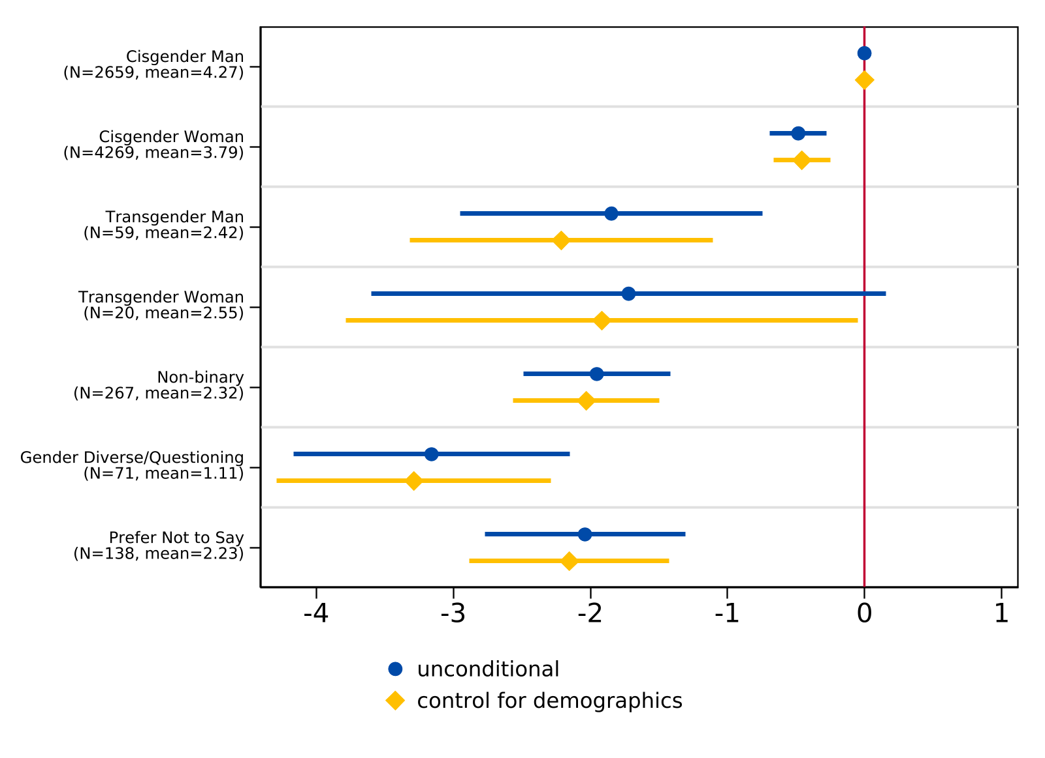
Figure 1. Regression of the High School Experience Index on Gender Identity
Note. For the unconditional model, n = 7,483. For the model controlling for demographics (race/ethnicity and parental level of education), n = 7,464. The lines indicate 95% confidence intervals while the sample frequency and mean index of each gender identity are reported in parentheses. The vertical line at 0 represents the coefficient for the reference group (cisgender man). See the Data Analysis section for details on the construction of the high school experience index.
We observe a similar pattern by sexual orientation (Table 3). Relative to straight/heterosexual students (mean = 4.1), all other sexual orientation groups report significantly lower high school experience scores. Students who prefer not to disclose their sexual orientation (mean = 2.9) and bisexual/pansexual/omnisexual students (mean = 3.1) report the largest gaps, while asexual/aromantic/demisexual students (mean = 3.7) and gay or lesbian students (mean = 3.6) report somewhat smaller but still significant differences. These differences remain statistically significant after controlling for race/ethnicity, parental education, as well as assigned sex at birth (Figure 2). While not causal, these results suggest an association between both gender identity/sexual orientation and students’ experiences in high school, which we consider in later analyses.
Table 3. General High School Experience by Sexual Orientation
 | n | Mean
Straight/heterosexual | 5,159 | 4.1
Gay or lesbian | 329 | 3.6
Bisexual/pansexual/omnisexual | 1,136 | 3.1
Asexual/aromantic/demisexual | 182 | 3.7
Other/queer/questioning | 131 | 3.2
Prefer not to say | 505 | 2.9
Total | 7,442 | 3.8
Note. The general high school experience index only applies to students who reported non-missing values for all six high school experience items and ranges from -12 to 12 (negative values indicate a negative experience, positive values indicate a positive experience, and zero indicates a neutral experience). High school experience items are available in Appendices B and C.

Figure 2. Regression of the High School Experience Index on Sexual Orientation
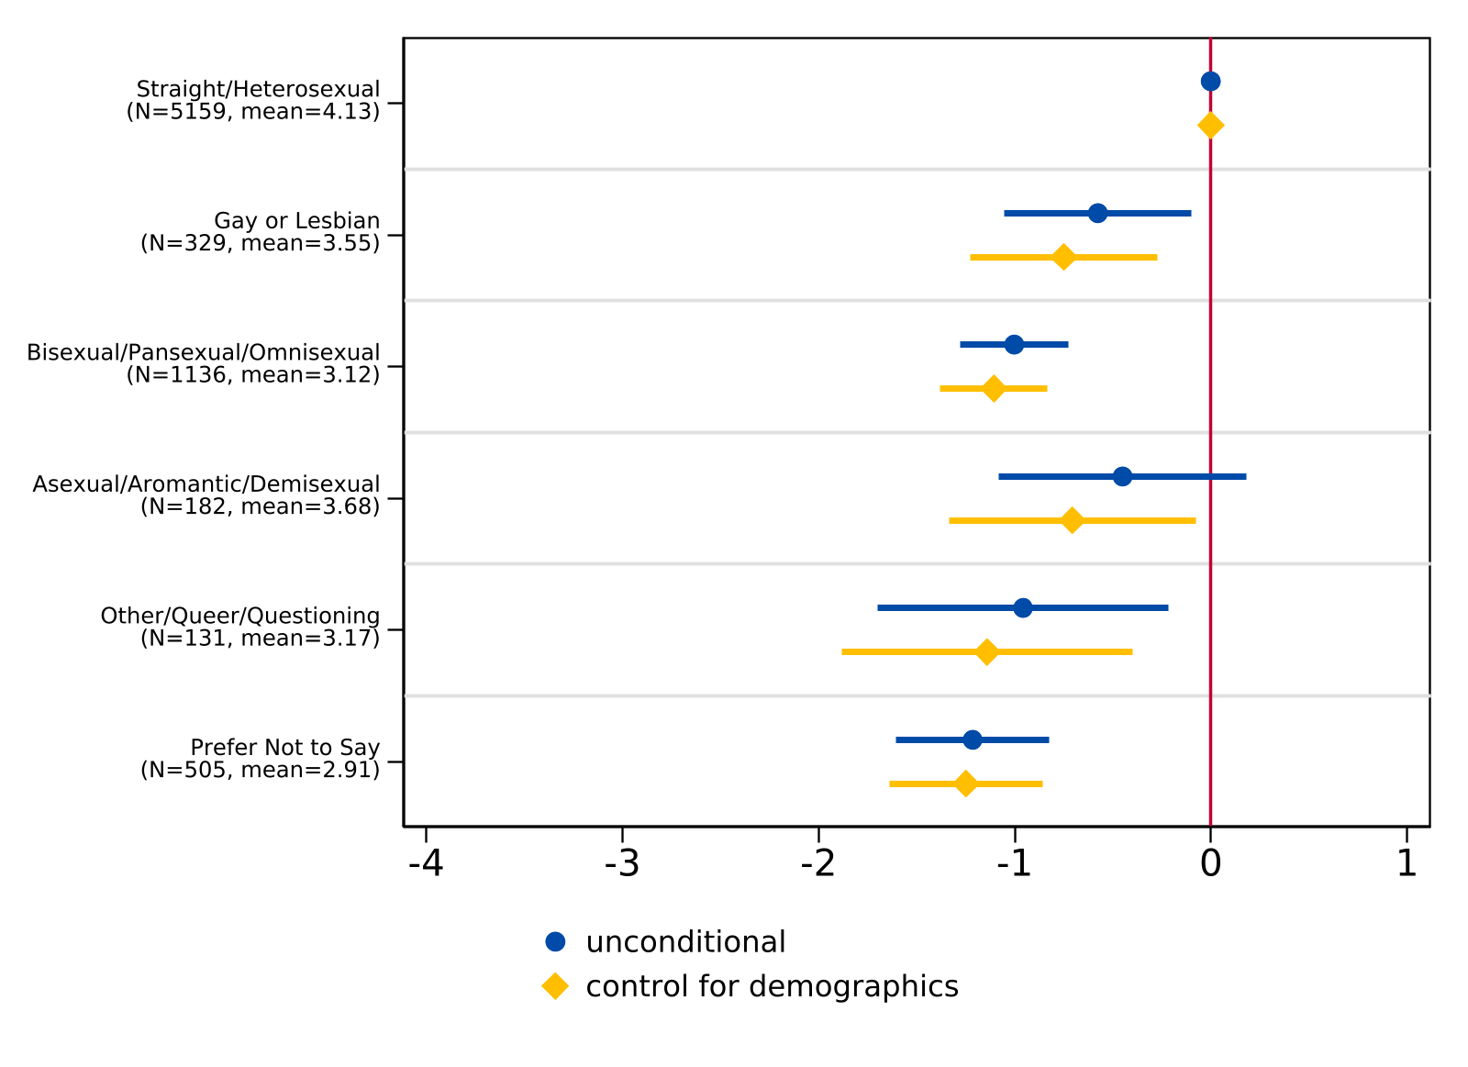
Note. For the unconditional model, n = 7,483. For the model controlling for demographics (race/ethnicity and parental level of education), n = 7,464. The lines indicate 95% confidence intervals while the sample frequency and mean index of each sexual orientation are reported in parentheses. The vertical line at 0 represents the coefficient for the reference group (straight/heterosexual). See the Data Analysis section for details on the construction of the high school experience index.

Bullying in High School
Figure 3 presents the frequency of bullying students reported experiencing in high school by gender identity and sexual orientation. Across all respondents, approximately 77% of students reported not being bullied or harassed on school property in the past year, while roughly 10% reported being bullied once, 9% reported being bullied two to three times, and about 4% were bullied four or more times. However, these rates varied considerably by gender identity. Among cisgender men, nearly 84% reported no bullying compared to only about 35% of transgender students and 54% of nonbinary and gender diverse/questioning students. Moreover, transgender students reported the highest rates of repeated victimization, as approximately 27% were bullied two to three times and nearly 16% experienced bullying four or more times — rates far exceeding those of any other gender identity. Nonbinary and gender diverse/questioning students also reported elevated rates of bullying relative to their cisgender peers, with roughly 23% reporting two to three incidents and about 10% reporting four or more.
Figure 3. Frequency of Bullying/Harassment in the Past Year

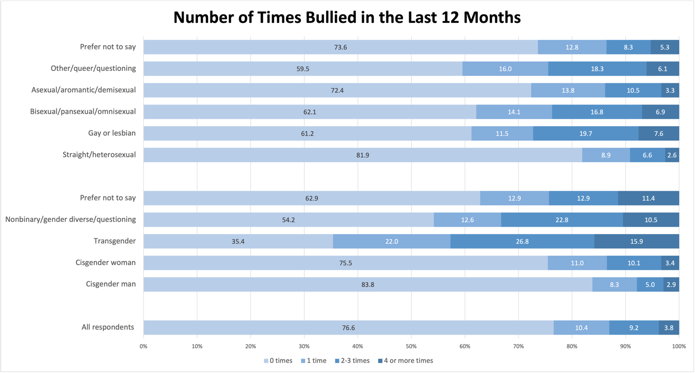
Note. Rates depicted in the figure represent the sample of students that responded to questions about bullying and harassment (n = 7,512 for disaggregation by gender, and n = 7,471 for disaggregation by sexual orientation).
Patterns by sexual orientation revealed similar disparities. While approximately 82% of straight/heterosexual students reported no bullying in the past year, this figure dropped to about 61% for gay or lesbian students and 62% for bisexual, pansexual, and omnisexual students. Students identifying as other, queer, or questioning also reported lower rates of no bullying (about 60%) and higher rates of repeated victimization compared to their heterosexual peers. Asexual, aromantic, and demisexual students reported rates closer to the overall average, though still below those of heterosexual students.
Among respondents who reported being bullied one or more times, we further examined whether students attributed the bullying to their gender identity or sexual orientation (Figure 4). Overall, about 55% of students that were bullied indicated they had been harassed because of their gender or sexual orientation. This figure, however, masks stark differences across identity groups. Among transgender students who reported being bullied (n = 42), all attributed the bullying to their gender identity or sexual orientation, and nearly 88% of nonbinary and gender diverse/questioning students who were bullied reported the same. In contrast, only about 35% of cisgender men and 51% of cisgender women who were bullied attributed it to gender or sexual orientation. Disparities were just as pronounced across sexual orientation: approximately 97% of gay or lesbian students who experienced bullying reported it was related to their gender or sexual orientation, compared to 28% of straight/heterosexual students. These patterns underscore that LGBTQ+ students not only experience higher rates of bullying overall but are also disproportionately targeted because of their identity.
Figure 4. Student Responses to “During the Past 12 Months, Were You Harassed or Bullied for Your Gender Identity or Sexual Orientation?”
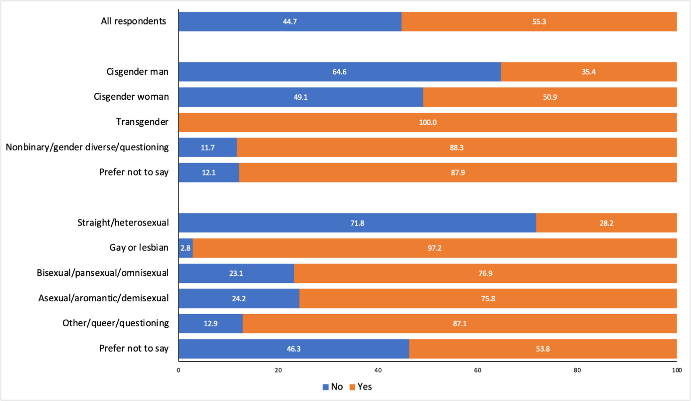
Note. Rates depicted in the figure represent the sample of students that reported being bullied or harassed more than once (n = 960 for disaggregation by gender, and n = 958 for disaggregation by sexual orientation).
Bullying as a Potential Mediator of High School Experiences
To investigate whether identity-based victimization helps to explain the differences we observe in high school experience by gender identity and sexual orientation, we estimated additional models that control for the frequency of bullying or harassment in the past year (full results presented in Appendix I). Adding bullying as a covariate attenuates the coefficients for gender identity; for example, the gap between gender diverse/questioning students and cisgender men narrows from -3.29 to -2.46 index points, and the gap for nonbinary students narrows from -2.03 to -1.44, though both remain significant. Additionally, across all gender identity categories, the R-squared increases from 0.034 (demographics only) to 0.072 (demographics plus bullying), indicating that bullying frequency explains a meaningful share, but not all, of the variation in students’ high school experiences.
A similar pattern emerges by sexual orientation (Appendix Figure I2). After controlling for bullying, the coefficient for gay or lesbian students is no longer statistically significant, suggesting that the lower high school experience reported by this group is largely attributable to experiences of bullying and harassment. The gap for bisexual/pansexual/omnisexual students narrows from -1.11 to -0.72 but remains significant, indicating that bullying also explains some of the differences for these students. Further controlling for assigned sex at birth produces only modest additional attenuation. These results suggest bullying is a meaningful mediator of the relationship between gender identity, sexual orientation, and overall high school experience, though it does not fully account for the observed disparities.

Concerns About College
Students were also asked about their concerns ahead of the transition to college. We constructed three indices of worry using PCA eigenvectors (summary statistics of the PCA constructs are reported in Table 4), including: (1) general worries; (2) worries about discrimination (including gender, sexuality, race, and religion); and (3) worries about financial burdens (including tuition and living costs). For summary statistics of the survey items used to construct these dimensions by gender identity and sexual orientation, see Appendix D. Together, these components explained 56.0% of the variance in overall worries about the transition to college.

Table 4. College Concern Items and Results from Principal Component Analysis (PCA)
 | N | Mean
Items:
How worried are you about…
Affording tuition fees? | 7,957 | 1.8
Living expenses? | 7,956 | 1.7
Performing well academically? | 7,958 | 1.5
Balancing work obligations? | 7,943 | 1.6
Balancing family obligations? | 7,941 | 1.1
Finding community? | 7,934 | 1.3
Living away from home? | 7,948 | 0.9
Having adequate support for emotional and mental health needs? | 7,944 | 1.1
Discrimination based on gender? | 7,886 | 0.4
Discrimination based on sexual orientation? | 7,876 | 0.3
Discrimination based on race? | 7,895 | 0.5
Discrimination based on religion? | 7,891 | 0.2
PCA constructs:
General worries (32.0%) | 7,706 | 3.8
Worries about discrimination (13.8%) | 7,706 | 1.2
Worries about financial burdens (10.3%) | 7,706 | 0.6
Note. The first twelve rows are survey items related to college worries. Each item ranges from 0 (not worried at all) to 3 (very worried). The last three rows indicate the three constructs: (1) general worries ranges from 0 to 10.23; (2) worries about discrimination ranges from -3.83 to 5.12; and (3) worries about financial burdens ranges from -3.64 to 3.65. Constructs were only created for high school students that reported non-missing values for all twelve items. The PCA proportion explained is reported in parentheses after each construct. See the Data Analysis section for details on the construction of the worry indices.
In terms of broad concerns, we find trans and gender expansive students experience a higher level of general worries compared to cisgender students. When we correlated these worries to students’ high school experiences, there appeared to be a negative, fairly weak correlation between high school experience and general worries about college; that is, students who reported more negative experiences in high school, on average, reported more worries about college. However, there is almost no correlation between high school experience and worries about discrimination or financial burdens, respectively.
Regression estimates for each component of worry by gender identity, with and without controls, are presented in Figures 5 through 7. In all regressions, cisgender men was set as the baseline comparison category. In terms of general college worries, among trans and gender expansive students, we find no statistical differences between different gender identities (Figure 5). That is, the general worries of transgender men, transgender women, and nonbinary or gender questioning students were significantly higher than cisgender men, but not significantly different from each other.
Figure 5. Regression of General Worries About College on Gender Identity Categories
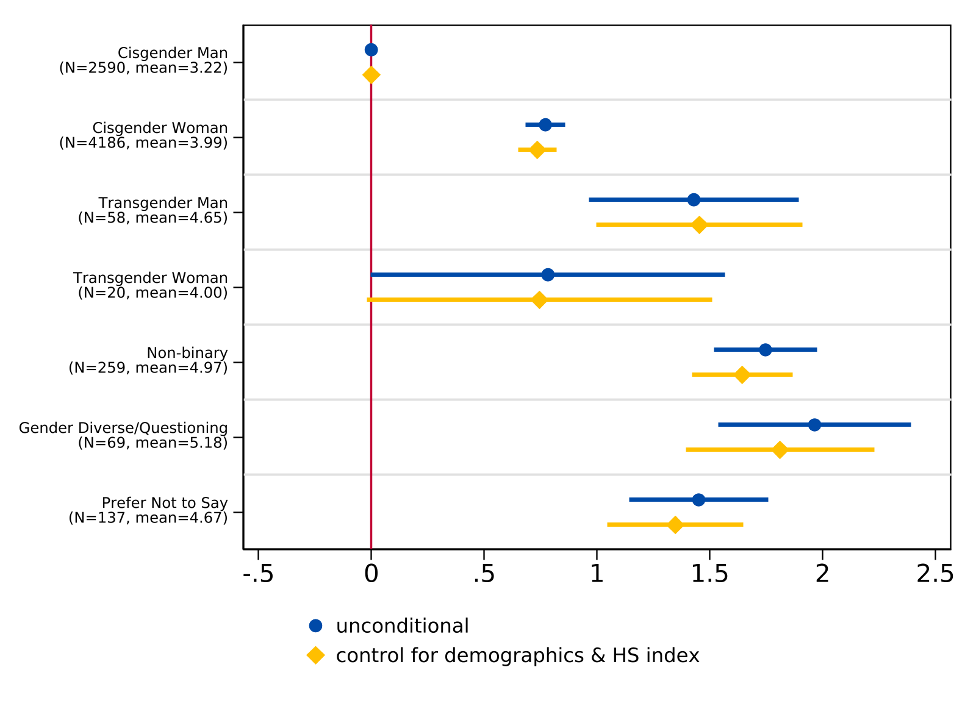
Note. We estimate regression models with gender indicators for an unconditional model (n = 7,319) and include race/ethnicity indicators, parental education indicators, and a constructed high school experience index as covariates for the specification with control variables (n = 7,276). The lines indicate 95% confidence intervals while the sample frequency and mean for each gender identity are reported in parentheses. The vertical line at 0 represents the coefficient for the reference group (cisgender man). See the Data Analysis section for details on the construction of the worry indices.
Additionally, results illustrate that trans and gender expansive students maintain higher levels of worry about discrimination compared to cisgender students (Figure 6), as the magnitude of the difference between transgender men and cisgender men exceeds the mean level of worry about discrimination for cisgender men. Additionally, among trans and gender expansive students, transgender students report higher levels of worry about discrimination compared to nonbinary and gender diverse/questioning students, although this estimate is somewhat noisy due to sample size. Finally, Figure 7 suggests that worries about financial burdens do not differ by gender identity.

Figure 6. Regression of Worries About Discrimination in College on Gender Identity Categories
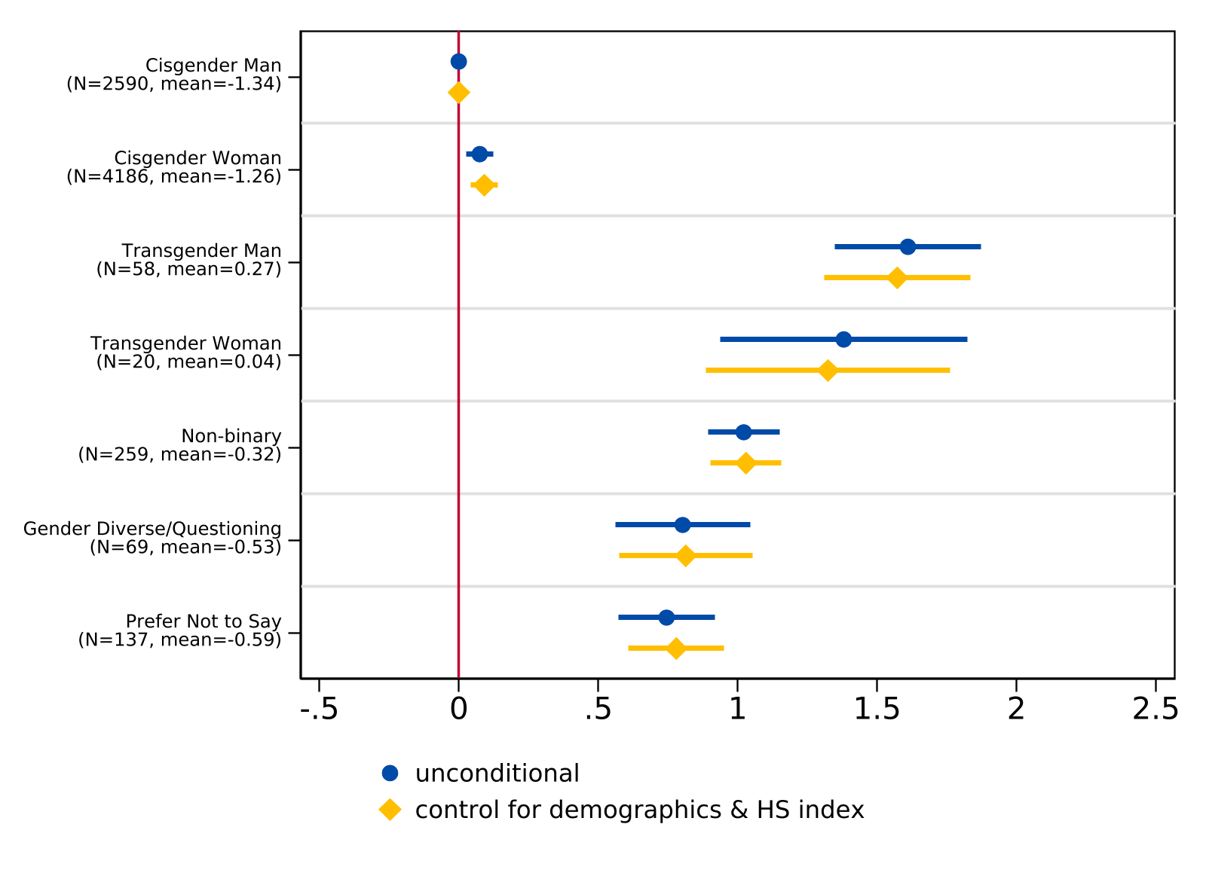
Note. We estimate regression models with gender indicators for an unconditional model (n = 7,319) and include race/ethnicity indicators, parental education indicators, and a constructed high school experience index as covariates for the specification with control variables (n = 7,276). The lines indicate 95% confidence intervals while the sample frequency and mean for each gender identity are reported in parentheses. The vertical line at 0 represents the coefficient for the reference group (cisgender man). See the Data Analysis section for details on the construction of the worry indices.

Figure 7. Regression of Worries About Financial Burdens in College on Gender Identity Categories
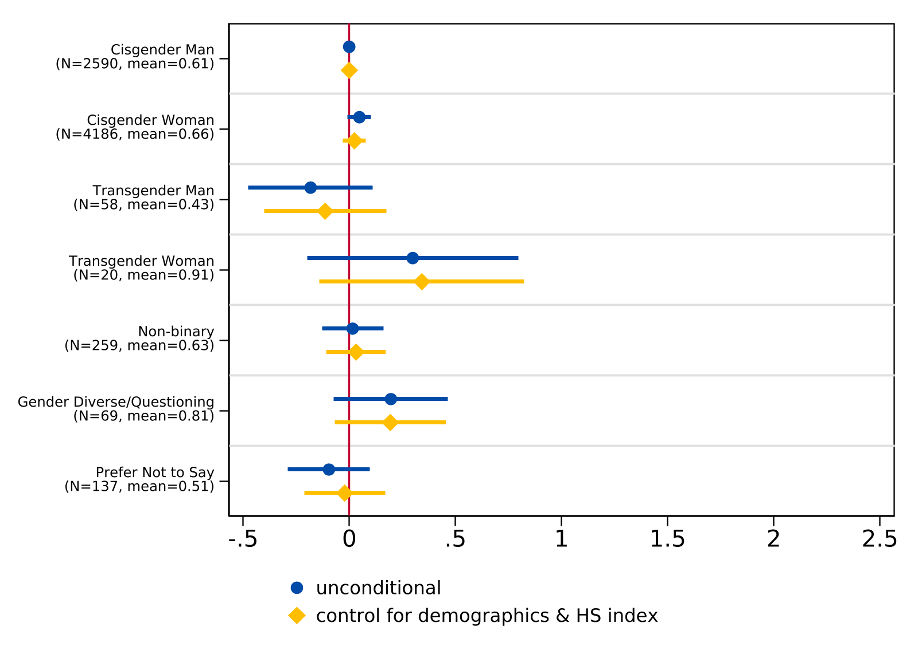
Note. We estimate regression models with gender indicators for an unconditional model (n = 7,319) and include race/ethnicity indicators, parental education indicators, and a constructed high school experience index as covariates for the specification with control variables (n = 7,276). The lines indicate 95% confidence intervals while the sample frequency and mean for each gender identity are reported in parentheses. The vertical line at 0 represents the coefficient for the reference group (cisgender man). See the Data Analysis section for details on the construction of the worry indices.
We find a similar pattern when examining college concerns by sexual orientation (Figure 8), as non-heterosexual students report significantly higher levels of general worries compared to straight/heterosexual students. The magnitude of these differences is fairly consistent across sexual orientation categories, with point estimates ranging from roughly 0.5 to 1.0 units above straight/heterosexual students. Other/queer/questioning students report the highest level of general worries (mean = 4.58), though the confidence interval is wider due to a smaller sample size. These differences remain statistically significant after controlling for demographics and high school experience.
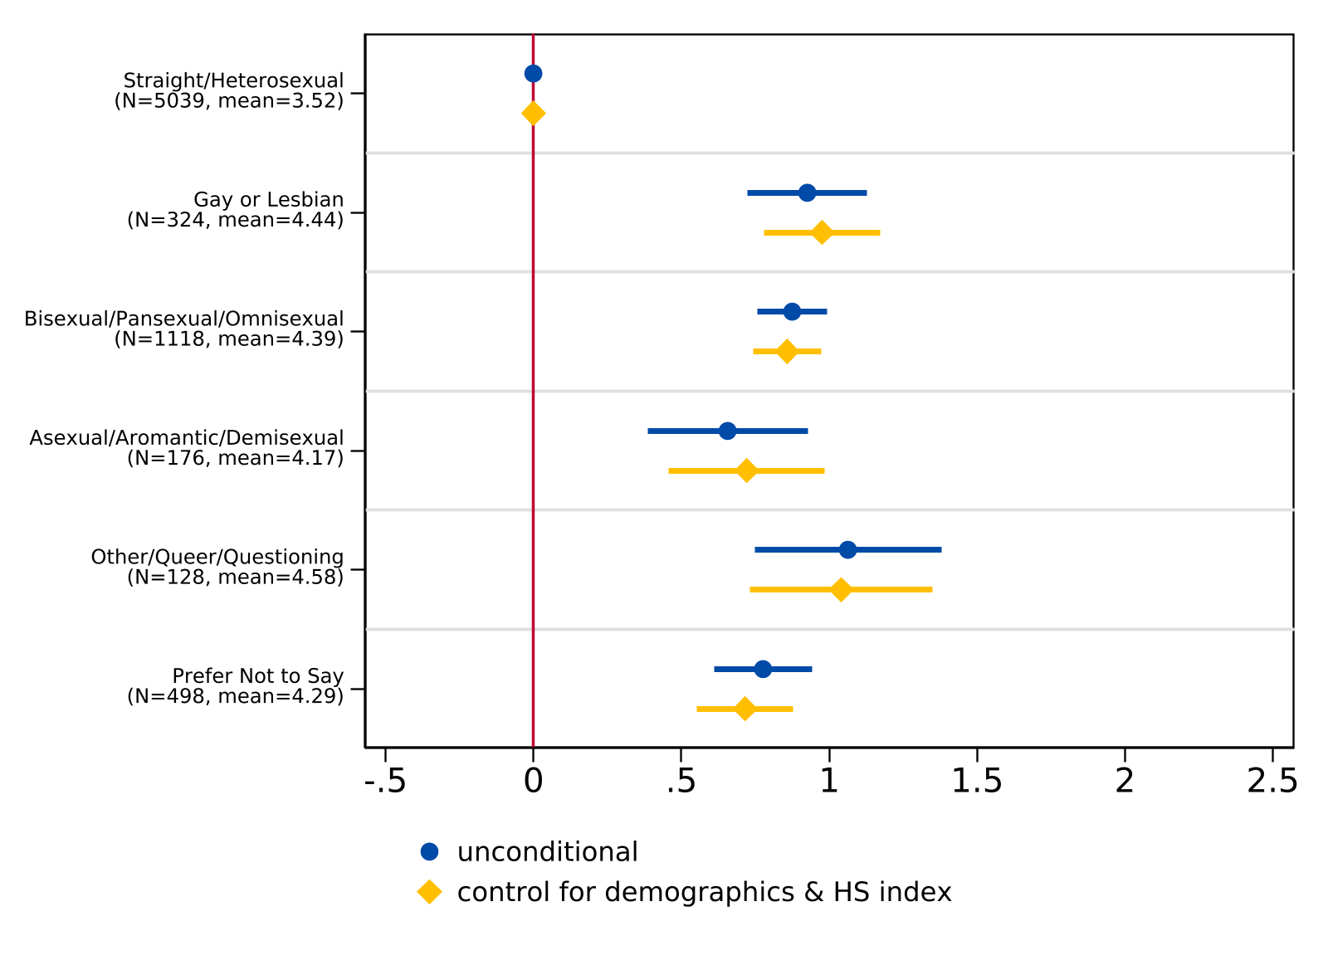
Figure 8. Regression of General Worries About College on Sexual Orientation Categories
Note. For the unconditional model, n = 7,283. For the model controlling for demographics (race/ethnicity and parental level of education), n = 7,263. The lines indicate 95% confidence intervals while the sample frequency and mean index of each sexual orientation are reported in parentheses. The vertical line at 0 represents the coefficient for the reference group (straight/heterosexual). See the Data Analysis section for details on the construction of the worry indices.
Worries about discrimination also differ significantly by sexual orientation (Figure 9), as non-heterosexual students also report higher levels of worry about discrimination relative to straight/heterosexual students (mean = -1.39). Among these students, asexual/aromantic/demisexual and other/queer/questioning students report the largest differences, while bisexual/pansexual/omnisexual students report somewhat smaller but still significant differences. These estimates are robust to the inclusion of demographic controls and the high school experience index.

Figure 9. Regression of Worries about Discrimination in College on Sexual Orientation Categories
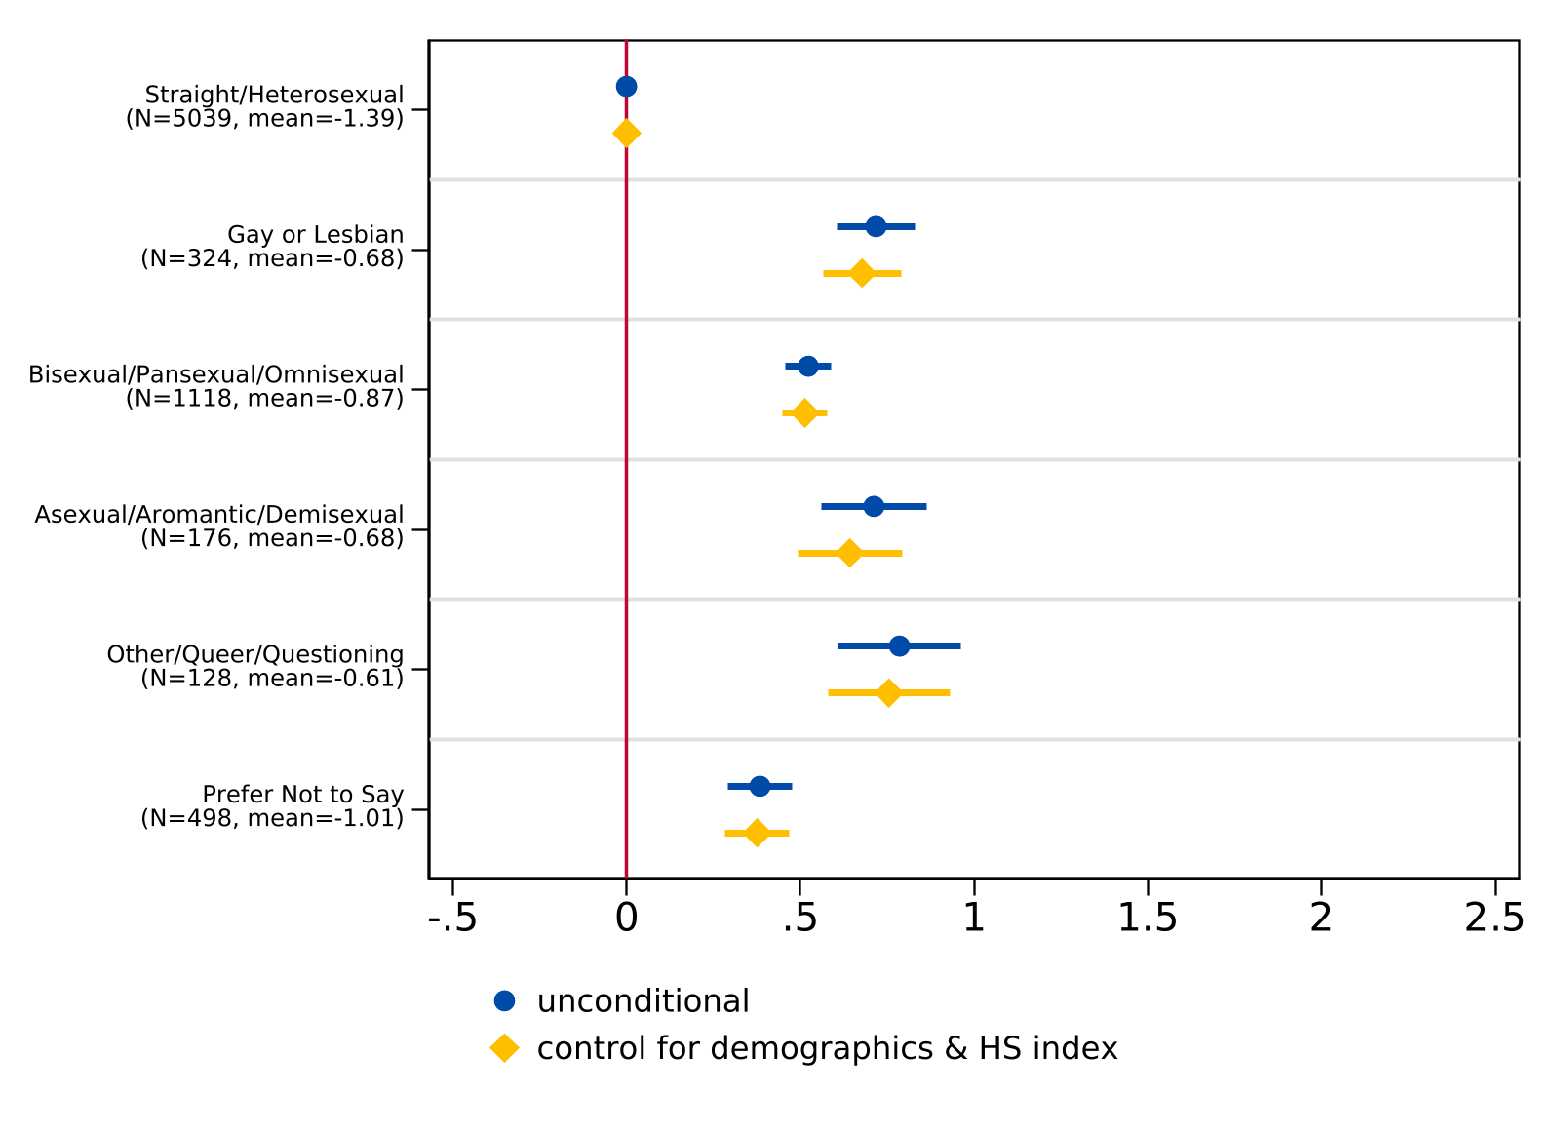
Note. For the unconditional model, n = 7,283. For the model controlling for demographics (race/ethnicity and parental level of education), n = 7,263. The lines indicate 95% confidence intervals while the sample frequency and mean index of each sexual orientation are reported in parentheses. The vertical line at 0 represents the coefficient for the reference group (straight/heterosexual). See the Data Analysis section for details on the construction of the worry indices.
As with gender identity, worries about financial burdens also do not differ meaningfully by sexual orientation (Figure 10). Point estimates are close to zero for most groups and confidence intervals generally overlap with the reference line, suggesting that financial concerns about college are not strongly associated with sexual orientation.

Figure 10. Regression of Worries about Financial Burdens in College on Sexual Orientation Categories
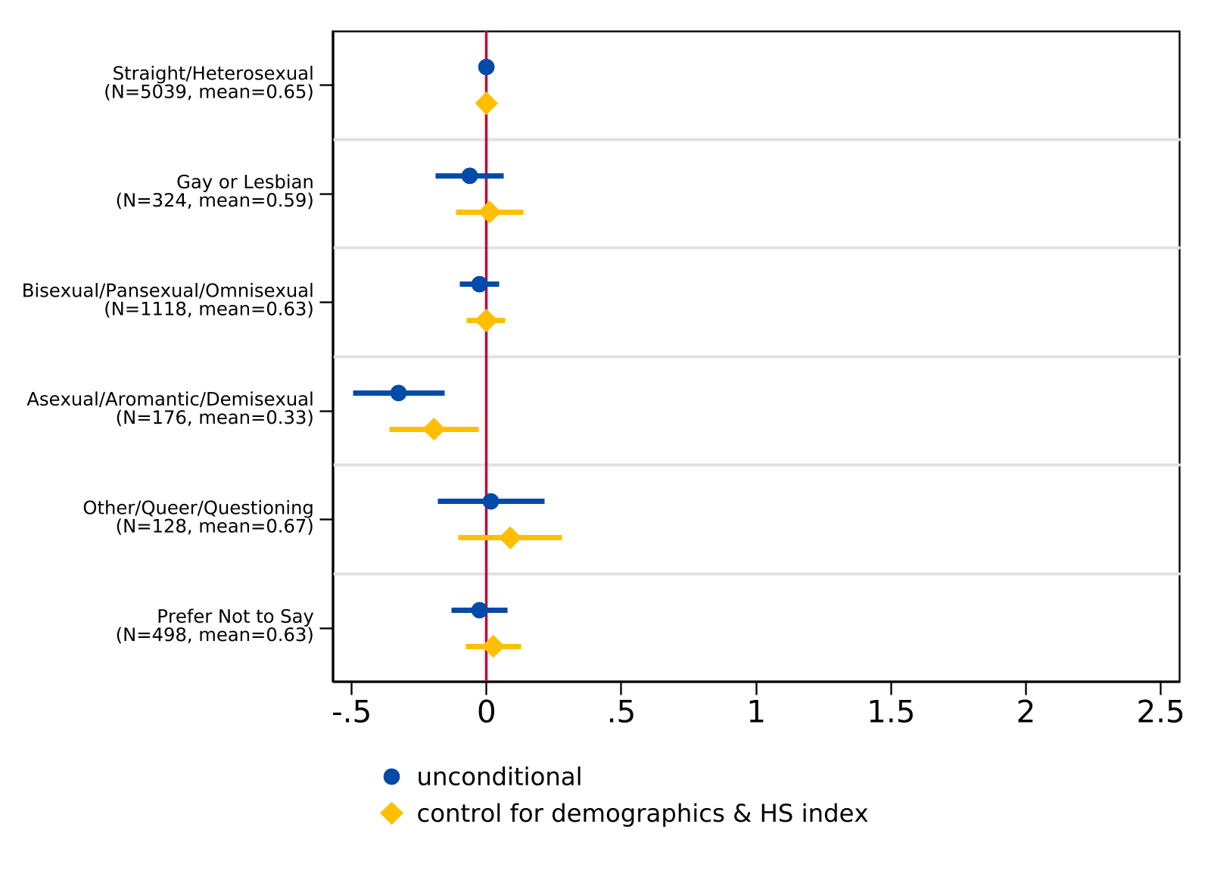
Note. For the unconditional model, n = 7,283. For the model controlling for demographics (race/ethnicity and parental level of education), n = 7,263. The lines indicate 95% confidence intervals while the sample frequency and mean index of each sexual orientation are reported in parentheses. The vertical line at 0 represents the coefficient for the reference group (straight/heterosexual). See the Data Analysis section for details on the construction of the worry indices.

Bullying as a Potential Mediator of College Worries
To investigate whether bullying experiences help to explain the observed differences in college worries, we estimated additional models that control for the frequency of bullying or harassment students experienced in the past year alongside demographic controls and the high school experience index (results are presented in Appendix J).
For general worries by gender identity, controlling for bullying does not substantively change the pattern of results (Appendix Figure J1). For example, while the coefficient for nonbinary and gender diverse/questioning students decreases (from 1.64 to 1.49, and from 1.81 to 1.62, respectively), coefficients for trans and gender expansive students remain significantly higher than cisgender men. The bullying coefficients themselves are positive and significant, suggesting that students who experienced more frequent bullying report higher general worries about college, although this association does not fully account for the gender identity differences. We find a similar pattern for sexual orientation (Appendix Figure J2): in this case, all non-heterosexual student groups continue to report significantly higher general worries after controlling for bullying, with only modest attenuation of the coefficients.
For worries about discrimination, results are even more striking. After controlling for bullying, the coefficients for gender identity remain large and highly significant (Appendix Figure J3). Transgender men maintain the highest level of worry about discrimination relative to cisgender men (b = 1.48), followed by transgender women (b = 1.22), nonbinary students (b = 0.97), and gender diverse/questioning students (b = 0.73). The persistence of these large coefficients after controlling for bullying suggests that worry about discrimination is not simply a reflection of past bullying experiences but may reflect broader anticipation of discrimination in the college environment. By sexual orientation (Appendix Figure J4), all non-heterosexual students likewise maintain significantly elevated worries about discrimination after controlling for bullying, with other/queer/questioning students (b = 0.71) and asexual/aromantic/demisexual students (b = 0.62) reporting the largest differences.
Consistent with our earlier findings, worries about financial burdens remain unrelated to either gender identity or sexual orientation after controlling for bullying (Appendix Figures J5 and J6). The bullying coefficients themselves are small and largely non-significant in the financial burden models, confirming that financial concerns about college operate independently of both identity-based differences and bullying experiences.

Postsecondary Educational Plans
We next explore patterns in academic plans across gender identity, including college program type, intended field of study, and the highest degree students planned to pursue. Findings indicate that most students planned to enroll in a four-year college compared to a two-year college (Figure 11); however, more transgender and nonbinary students planned to enroll in four-year colleges compared to their cisgender peers. Conversely, students that identified as gender diverse or questioning intended to enroll in a two- or four-year college at nearly similar rates (49.3% and 50.7%, respectively).
Figure 11. Plans for College Enrollment by Gender Identity (n = 7,522) 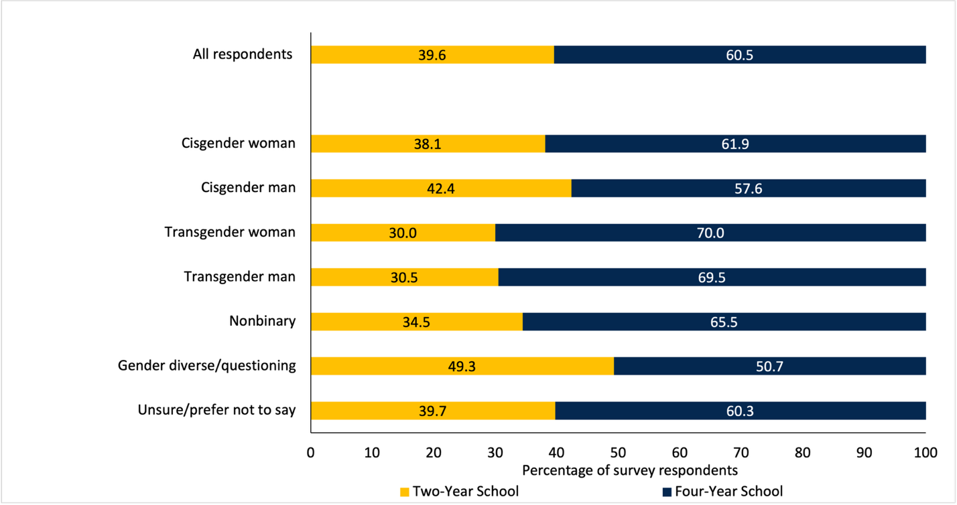
Differences also emerged in students’ intended field of study (Table 5). Overall, most students planned to study natural sciences (16.3%), engineering (16.2%), and health sciences (14.8%), including trans and gender expansive students, who often selected these majors at higher rates than their peers. For example, transgender women planned to study engineering at nearly 9 percentage points above the rate overall. Trans and gender expansive students were also more likely to pursue humanities and the arts, as gender diverse students (31.0%), transgender men (28.8%), nonbinary students (25.5%), and transgender women (25.0%) all indicated these fields at much higher rates than the sample overall (11.4%).
Table 5. Intended Field of Study by Gender Identity
 | Business | Engineering | Natural sciences | Social sciences | Humanities and arts | Health sciences | Education | Applied sciences | Public service | Undecided | N
All respondents | 10.0 | 16.2 | 16.3 | 12.3 | 11.4 | 14.8 | 3.5 | 3.4 | 4.8 | 7.5 | 7,499
Cisgender man | 12.1 | 30.0 | 12.2 | 7.9 | 8.9 | 8.0 | 1.4 | 7.0 | 4.3 | 8.4 | 2,662
Cisgender woman | 9.6 | 7.8 | 18.4 | 14.7 | 11.2 | 19.9 | 4.9 | 1.2 | 5.3 | 7.1 | 4,280
Transgender man | 1.7 | 13.6 | 22.0 | 15.3 | 28.8 | 6.8 | 5.1 | 1.7 | 1.7 | 3.4 | 59
Transgender woman | 10.0 | 25.0 | 10.0 | 10.0 | 25.0 | 0.0 | 0.0 | 15.0 | 0.0 | 5.0 | 20
Nonbinary | 3.0 | 12.0 | 19.9 | 15.4 | 25.5 | 7.9 | 3.0 | 3.4 | 3.4 | 6.7 | 267
Gender diverse/  questioning | 1.4 | 9.9 | 19.7 | 16.9 | 31.0 | 8.5 | 1.4 | 1.4 | 5.6 | 4.2 | 71
Prefer not to say | 5.0 | 19.3 | 18.6 | 12.9 | 17.9 | 9.3 | 2.9 | 2.1 | 3.6 | 8.6 | 140
N | 749 | 1,211 | 1,220 | 920 | 852 | 1,106 | 262 | 255 | 360 | 564 | 7,499
Note. Each cell represents the row percentage.
Students also indicated the highest degree they planned to complete (Figure 12). Across all respondents, over half (54.9%) planned to earn an advanced degree. Additionally, we find that more trans and gender expansive students indicated plans to earn a master’s or doctorate at higher rates compared to cisgender students. Among transgender women, of the 55.0% that planned to complete an advanced degree, 72.7% intended to earn a master’s degree—higher than any other gender identity we surveyed. Comparatively, transgender women, gender diverse/questioning students, and cisgender men were more likely to pursue an associate or vocational degree compared to other students, although transgender women and cisgender men appear to be outliers overall.
Figure 12. Plans for Degree Completion by Gender Identity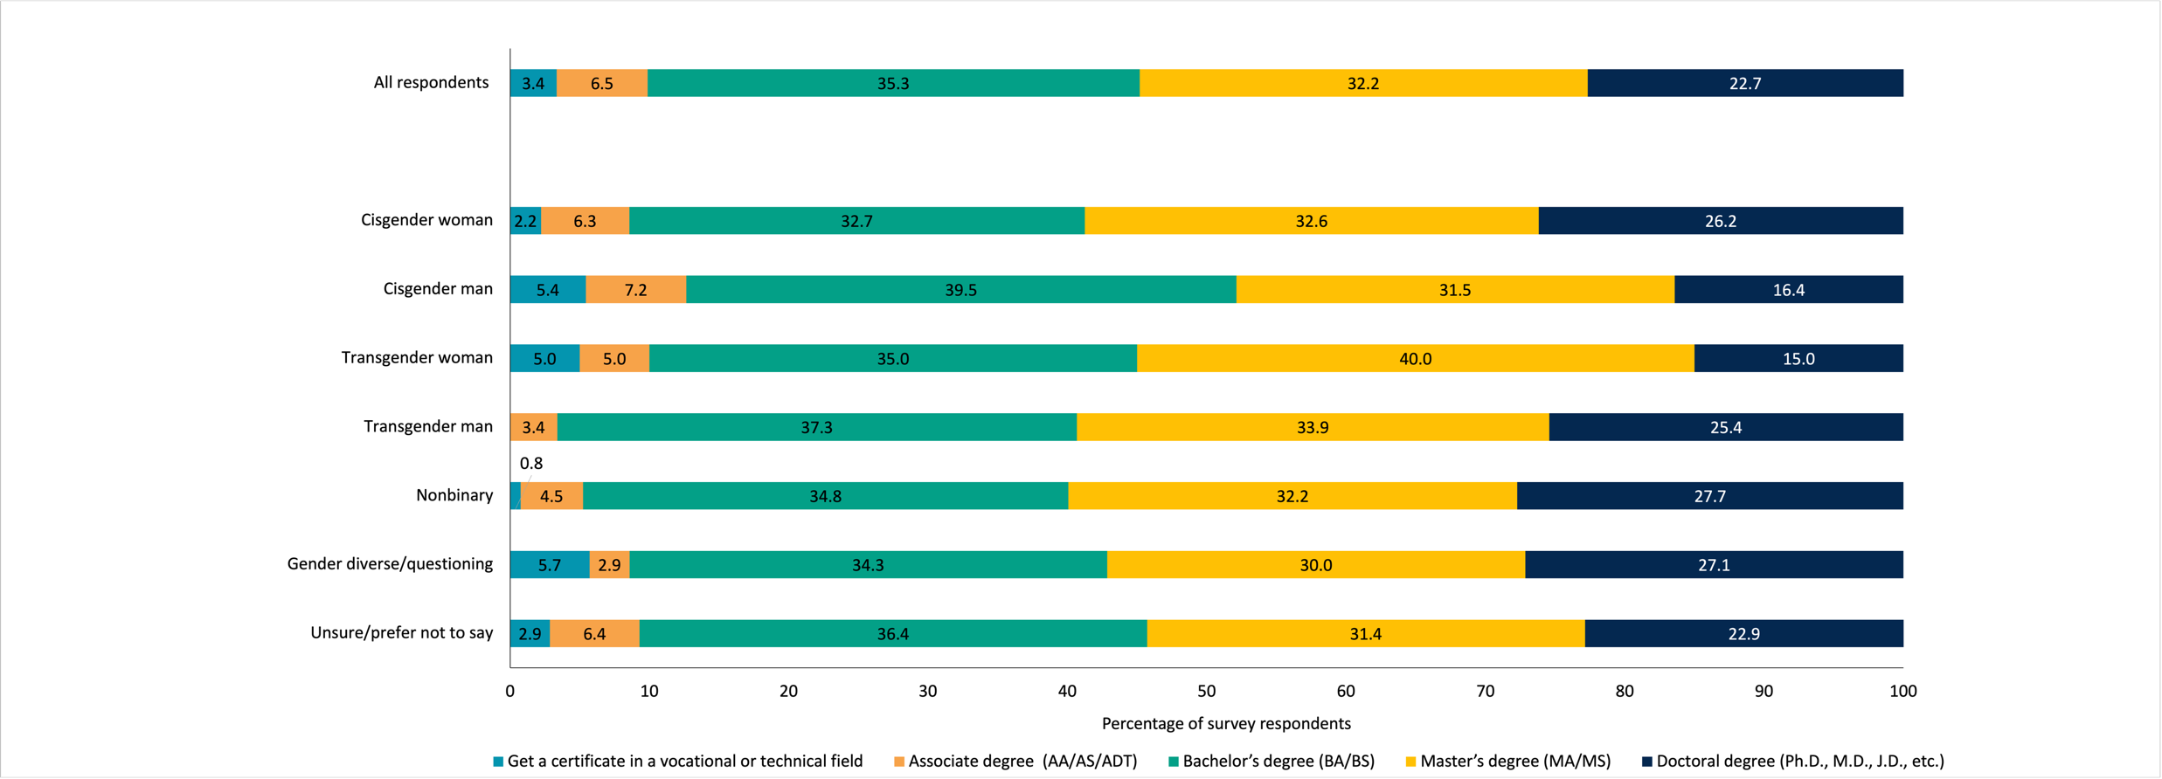
Note. Bars represent percentages (n = 7,497).
To examine whether descriptive differences in postsecondary plans persist after accounting for student demographics, we estimated logit models for intent to attend a four-year college and ordered logit models for highest degree aspirations by both gender identity and sexual orientation. Here, we report odds ratios, where values greater than one indicate higher odds relative to the reference category. We also report predicted probabilities from the ordered logit models as stacked bar charts evaluated at sample means in Appendix H.
For four-year enrollment by gender identity (Table 6), nonbinary students were significantly more likely than cisgender men to plan to attend a four-year institution, and this difference was robust to the inclusion of demographic controls. Cisgender women were also significantly more likely to plan to attend a four-year college in both specifications. Additionally, for gender diverse/questioning students, the odds ratio was less than one in both specifications, consistent with the descriptive finding that this group was roughly equally split between two- and four-year enrollment plans. For both transgender men and transgender women, the odds ratios were greater than one; however, estimates may be imprecise due to smaller sample size. In this case, we refrain from drawing conclusions about four-year enrollment for these categories based on the regression estimates alone and instead direct readers to the descriptive results reported in Figure 11.

Table 6. Logit Models: Intent to Attend a 4-Year College (Odds Ratios) by Gender Identity
 | (1) | (2)
Cisgender woman | 1.196*** | 1.282***
 | [1.084,1.319] | [1.154,1.424]
Transgender man | 1.676* | 1.481
 | [0.958,2.933] | [0.816,2.686]
Transgender woman | 1.717 | 1.516
 | [0.658,4.482] | [0.549,4.190]
Nonbinary | 1.400** | 1.341**
 | [1.075,1.822] | [1.015,1.771]
Gender diverse/questioning | 0.757 | 0.681
 | [0.472,1.213] | [0.412,1.125]
Prefer not to say | 1.117 | 1.100
 | [0.790,1.579] | [0.754,1.603]
Observations | 7522 | 7498
Demographic controls | No | Yes
Note. Exponentiated coefficients; 95% confidence intervals included in brackets.
* p < 0.10, ** p < 0.05, *** p < 0.01
Results by sexual orientation were broadly consistent. For four-year enrollment (Table 7), gay or lesbian students and bisexual/pansexual/omnisexual students were significantly more likely to plan to attend a four-year college, and these differences persisted after controlling for demographics. The odds ratios for asexual/aromantic/demisexual and other/queer/questioning students were greater than one and significant in the unconditional models, but no longer significant with the inclusion of demographic controls. This suggests that some of the descriptive differences for these groups may reflect compositional variation in race/ethnicity or parental education.

Table 7. Logit Models: Intent to Attend a 4-Year College (Odds Ratios) by Sexual Orientation
 | (1) | (2) | (3)
Gay or lesbian | 1.692*** | 1.498*** | 1.496***
 | [1.327,2.156] | [1.159,1.935] | [1.157,1.935]
Bisexual/pansexual/  omnisexual | 1.410*** | 1.347*** | 1.264***
 | [1.233,1.614] | [1.169,1.553] | [1.093,1.462]
Asexual/aromantic/  demisexual | 1.608*** | 1.190 | 1.116
 | [1.168,2.213] | [0.845,1.675] | [0.790,1.575]
Other/queer/  questioning | 1.413* | 1.186 | 1.121
 | [0.979,2.039] | [0.803,1.750] | [0.758,1.657]
Prefer not to say | 1.001 | 0.899 | 0.863
 | [0.832,1.204] | [0.737,1.096] | [0.707,1.054]
Observations | 7481 | 7456 | 7446
Demographic controls | No | Yes | Yes
Assigned sex at birth | No | No | Yes
Note. Exponentiated coefficients; 95% confidence intervals included in brackets.
* p < 0.10, ** p < 0.05, *** p < 0.01
For degree aspirations (Tables 8 and 9), ordered logit results reported as odds ratios indicate that nonbinary students had significantly higher degree aspirations than cisgender men (OR = 1.80, 95% CI [1.43, 2.26]), with the largest and most precisely estimated odds ratio among the trans and gender expansive categories, a difference that remained robust with demographic controls (OR = 1.83, 95% CI [1.45, 2.30]). Transgender men also reported significantly higher degree aspirations in both the unconditional (OR = 1.74, 95% CI [1.10, 2.75]) and controlled (OR = 1.66, 95% CI [1.03, 2.67]) models. Gender diverse/questioning students had 1.58 times the odds of aspiring to a higher degree category in the unconditional model (95% CI [1.02, 2.45]), though this attenuated to marginal significance with controls (OR = 1.54, 95% CI [0.99, 2.41]). For transgender women, the small sample size (n = 20) produced estimates that were too imprecise to support meaningful inference (OR = 1.19, 95% CI [0.55, 2.61]); while the descriptive patterns suggest transgender students as a whole report lower rates of certificate and associate degree aspirations and comparable or higher rates of master’s degree aspirations relative to cisgender men, the regression models lack the statistical power to confirm these patterns. We therefore direct readers to the descriptive results presented in Figure 12 rather than interpret these coefficients substantively.
Table 8. Ordered Logit Models: Highest Degree Plans (Odds Ratios) by Gender Identity
 | (1) | (2)
Cisgender woman | 1.627*** | 1.734***
 | [1.489,1.777] | [1.585,1.896]
Transgender man | 1.738** | 1.661**
 | [1.098,2.750] | [1.032,2.674]
Transgender woman | 1.194 | 1.050
 | [0.548,2.605] | [0.477,2.311]
Nonbinary | 1.798*** | 1.829***
 | [1.432,2.257] | [1.451,2.304]
Gender diverse/questioning | 1.584** | 1.541*
 | [1.023,2.453] | [0.985,2.411]
Prefer not to say | 1.368** | 1.296
 | [1.005,1.863] | [0.945,1.778]
Observations | 7497 | 7475
Demographic Controls | No | Yes
Exponentiated coefficients; 95% confidence intervals in brackets
* p < 0.10, ** p < 0.05, *** p < 0.01
In terms of sexual orientation, gay or lesbian students (OR = 1.53, 95% CI [1.25, 1.87]) and bisexual/pansexual/omnisexual students (OR = 1.64, 95% CI [1.45, 1.84]) consistently reported higher degree aspirations across both specifications. Additionally, the odds ratios for asexual/aromantic/demisexual students (OR = 1.52, 95% CI [1.17, 1.98]) and other/queer/questioning students (OR = 1.44, 95% CI [1.06, 1.96]) were found to only be significant in our unconditional models.

Table 9. Ordered Logit Models: Highest Degree Plans (Odds Ratios) by Sexual Orientation
 | (1) | (2) | (3)
Gay or lesbian | 1.527*** | 1.388*** | 1.353***
 | [1.250,1.867] | [1.130,1.704] | [1.101,1.663]
Bisexual/pansexual/omnisexual | 1.636*** | 1.587*** | 1.386***
 | [1.454,1.840] | [1.408,1.788] | [1.226,1.566]
Asexual/aromantic/demisexual | 1.522*** | 1.251 | 1.079
 | [1.168,1.983] | [0.955,1.638] | [0.822,1.416]
Other/queer/questioning | 1.440** | 1.293 | 1.117
 | [1.056,1.963] | [0.941,1.777] | [0.811,1.537]
Prefer not to say | 1.162* | 1.049 | 0.957
 | [0.986,1.370] | [0.887,1.240] | [0.808,1.132]
Observations | 7456 | 7433 | 7423
Demographic controls | No | Yes | Yes
Assigned sex at birth | No | No | Yes
Exponentiated coefficients; 95% confidence intervals in brackets
* p < 0.10, ** p < 0.05, *** p < 0.01

Qualitative Findings
The survey also asked respondents about challenges they anticipated as well as what they were the most excited about ahead of the transition to college. Although a full qualitative analysis of these data is beyond the scope of this paper, we highlight the social concerns and hopes raised by transgender, nonbinary, and gender diverse/questioning students in their responses.

Social Challenges and Discrimination
In open-ended responses, nearly one-quarter of trans and gender expansive students identified social challenges as a concern, as many worried about making new friends or whether they would make friends at all. A nonbinary student described, “Making friends has been a challenge for me in the past when I had to go somewhere new and didn’t know anyone, so it might take a little while to get close with people.” Transgender students also expressed concerns over finding community once they entered college, including worries they may not fit in, or may feel alone or overwhelmed in a new social environment. These worries also included fears of discrimination; multiple students noted concerns about transphobia, coming out to others, and seeing kids from their high school. Moreover, the most intense social concern came from one nonbinary student who shared: “I could die from hate crimes.”

Finding Friends and Community
In contrast, over 36% of trans and gender expansive students were excited about the social aspects of college, as students anticipated meeting new people and building new friendships despite some apprehension. One nonbinary student expressed, “I will be making friends on my own, which is scary, but something to look forward to.” Several students looked forward to finding community, with one gender diverse student writing: “[I am excited] to be able to build a community for myself where I truly feel that I belong.” Additionally, students anticipated meeting other students like themselves. One nonbinary student explained, “I’m most excited about the friendships I will form with people who share the same mindset as me.” Students also wanted to meet people with similar academic interests. As one gender diverse/questioning student noted: “I’m really excited to be part of a supportive and engaging community… [and] be around people with a similar drive for learning and an appreciation of education.”
Several students were also excited to attend a college where they could access gender-affirming healthcare and housing. One gender diverse/questioning student mentioned, “I’m also going to be downtown for college and I know that the college I’m going to is very LGBTQ+ friendly.” Another nonbinary student explained, “I’m also looking forward to receiving certain medical treatment at my college’s health center that I currently don’t have access to.”
Additionally, some trans and gender expansive students looked forward to the opportunity to leave their home environment. Students described a desire to “[get] away from home and a community that I was almost constantly harassed in,” “leave my abusive household,” and “be away from home… [and] finally hav[e] my own autonomy.” One trans woman added that leaving home and entering college explicitly offered “the ability to transition my gender identity, as my parents are opposed to it.” Together, these responses illustrate a pattern consistent with our quantitative findings: even as trans and gender expansive students report elevated concerns about discrimination and less positive high school experiences, they simultaneously express hope that college will offer safer, more affirming environments where they can build community and access the support they need.

Limitations
An important limitation to consider in this work is that our sample is self-selected and restricted to students that indicated plans to enroll in college in the fall after their senior year. In this case, our results speak to a group of students that made it to the 12th grade, filed a FAFSA or CADAA, and volunteered to participate in our survey. As such, results do not include students who dropped out prior to 12th grade, had other plans, or for whom college seemed out of reach—a population future research should examine in more detail, particularly for LGBTQ+ students. It is also important to consider that students’ plans can change—some students, despite their survey responses, may not enroll in college after all, underscoring that expectations to enroll do not always lead to enrollment (Klasik et al., 2025). Thus, these results reflect a unique sample of intended college-goers captured at one point in time. Future research on high school completion as well as college enrollment and retention by gender and sexual identities is needed.

Discussion and Conclusion
As high school experiences can influence students’ educational aspirations and later attainment, it is important to examine the extent to which these may differ by gender identity and sexual orientation. Our findings indicate that identity-based bullying explains a meaningful share of the observed disparities in the high school experiences of LGBTQ+ students. In fact, while controlling for bullying attenuates gaps in gender identity and sexual orientation, significant differences persist, suggesting that the challenges LGBTQ+ students face extend beyond victimization alone, consistent with prior research on gender-related victimization in high school (Hatchel et al., 2018; McBride, 2021).
Given these experiences, we examined students’ concerns ahead of college enrollment by gender identity and sexual orientation. Overall, trans and gender expansive students worried more about discrimination compared to cisgender students. Notably, these concerns persisted after controlling for bullying in high school, indicating that worries about discrimination in college may represent anticipatory concerns about future discrimination. Research indicates that the energy LGBTQ+ students expend navigating school and trying to avoid adverse experiences often detracts from the quality of their educational experience and ability to create community (Goldberg & Kuvalanka, 2018; Kersey & Voigt, 2021). Our findings suggest that this burden may extend into the college transition more broadly, particularly for trans and gender expansive students. In contrast, general worries about college (e.g., academic performance, finding community) and worries about financial burdens (e.g., tuition, living expenses) showed little association with bullying in high school, suggesting these concerns are driven by different factors.
However, despite any concerns, LGBTQ+ students still planned to pursue postsecondary schooling at significantly higher rates than their cisgender heterosexual peers. While these results differ from prior research (Feldman et al., 2022; Sansone, 2019; Wilkinson et al., 2021), the schooling experiences of LGBTQ+ students in our sample may include supports (whether at school or at home) potentially absent to students documented in other studies. For example, students may have had access to resources that can promote the well-being of trans and gender expansive students, such as social support from peers, family, and the community; school-inclusive policies; and extracurricular activities, among others (Fernandes et al., 2023). Moreover, barriers students might encounter (e.g., financial constraints, a lack of information) can drive them toward various degree pathways. For example, a student may perceive a mismatch between their ability level and certain colleges (Dillon & Smith, 2013), or have concerns about college (e.g., campus climate) (Dugan et al., 2012), driving them to select or avoid selecting a particular institution or pursuing a more advanced degree.
Results also indicated differences in students’ planned fields of study. While most students, regardless of gender identity, planned to study various STEM fields (e.g., engineering, natural sciences), trans and gender expansive students often selected these fields at higher rates. Moreover, trans and gender expansive students were more likely to pursue humanities and the arts, aligning with prior research that suggests LGBTQ+ students often select these fields as they believe they are more affirming (Linley et al., 2018) and inclusive than STEM or business (Forbes, 2022; Kersey & Voigt, 2021). These findings offer important insight into the majors and careers trans and gender expansive students plan to pursue and may be of interest to deans, department chairs, and other personnel involved in outreach and career opportunities.
Moreover, our findings carry several implications for education policy in California. First, the stark disparities in bullying rates and identity-based victimization documented in this study suggest that generic anti-bullying programs may be insufficient to address the experiences of LGBTQ+ students. For example, that 100% of transgender students that experienced bullying attributed their victimization to their gender identity or sexual orientation points to the need for targeted interventions that specifically address identity-based harassment, including expanded support for gender-sexuality alliances (GSAs) and professional development for school personnel on the needs of LGBTQ+ students. While California’s Seth’s Law (AB 9, 2012) already requires schools to adopt anti-bullying policies that enumerate sexual orientation and gender identity as protected categories, these findings indicate that substantial identity-based victimization persists, suggesting school districts may benefit from additional resources and accountability mechanisms to ensure policies are actively implemented.
Second, the patterns documented here, in which trans and gender expansive students report less positive high school experiences and elevated rates of identity-based bullying yet maintain elevated educational aspirations, are consistent with the social ecological theory of resilience framing this study (Ungar, 2011, 2012). In this case, the persistence of elevated educational aspirations in the face of documented adversity reflects the resilience and navigational capital LGBTQ+ students develop through experience in cis-normative environments (Pennell, 2016). This is underscored by our qualitative findings; even as students described fears of discrimination and hate crimes, they simultaneously expressed excitement about finding community and accessing gender-affirming resources in college. Policymakers and institutions should therefore ensure that students are supported with resources that address these concerns, which may include investments in bridge and/or mentoring programs at the high school and college level, as well as campus resources that are responsive to the needs of incoming LGBTQ+ students.
Third, this study highlights the critical need for the state to collect and disaggregate detailed data by gender identity and sexual orientation. The richness of the present data allowed us to identify disparities that would otherwise be invisible in datasets that treat LGBTQ+ students as a singular group or omit gender identity measures entirely. Presently, the California Healthy Kids Survey (CHKS) collects some information on gender and sexual identities; an anonymous survey of school climate, safety, and student wellness, the CHKS is administered biennially in grades 5, 7, 9, and 11 to students in schools that opt in with modules that collect gender identity (male, female, transgender) and sexual orientation data (gay/lesbian/bisexual, straight, not sure). However, our findings reveal distinct differences by gender identity and sexual orientation beyond these measures. This heterogeneity reinforces the importance of detailed data collection across gender and sexual identity subgroups, underscoring that LGBTQ+ students should not be treated as a monolith in terms of their college aspirations and broader academic plans (Feldman et al., 2022). As the state considers how to monitor school climate and student well-being going forward, broadening the identities captured in the CHKS as well as mandating its administration statewide would offer opportunities to further understand and address the needs of this population. However, we also recognize that in the current political climate, students may have legitimate concerns about disclosing their identities in institutional surveys. In this case, efforts to build this kind of evidence base will need to balance the analytic power of detailed identity data with robust protections for student privacy and confidentiality.
The present findings take on added significance in the current policy landscape. Since survey administration in 2023, federal policy for LGBTQ+ students has shifted considerably, including executive orders withdrawing the federal recognition of transgender identities; restrictions on Title IX protections; and efforts to curtail access to gender-affirming care for minors (Exec. Order No. 14168, 2025; U.S. Department of Education, 2025). At the same time, several states have enacted laws that limit the discussion of gender identity and sexual orientation in schools (Movement Advancement Project, 2025). In contrast, California has continued to strengthen state-level protections, including AB 1955 (the SAFETY Act), which prohibits school districts from requiring staff to disclose a student’s gender identity or sexual orientation to parents without the student’s consent (California Legislative Information, 2023; Equality California, 2025). This divergence underscores the importance of state-level data and state-level action. Our results suggest that, even within California’s comparatively protective policy environment, LGBTQ+ students experienced significant disparities in high school climate and identity-based victimization at the time of survey administration. As federal protections for LGBTQ+ students are rolled back, the role of state and local policy in addressing these disparities becomes even more critical. More broadly, our findings underscore the importance of California’s continued commitment to fostering safe, affirming educational environments and ensuring that all students, regardless of gender identity or sexual orientation, are supported in realizing their educational aspirations. As California approaches a new chapter of its education policy, we hope these findings will offer a foundation for evidence-based action on behalf of some of the state’s most vulnerable students.

References
Alvarado, S. E., & An, B. P. (2015). Race, friends, and college readiness: Evidence from the high school longitudinal study. Race and Social Problems, 7, 150–167. https://doi.org/ 10.1007/s12552-015-9146-5
Aragon, S. R., Poteat, V. P., Espelage, D. L., & Koenig, B. W. (2014). The influence of peer victimization on educational outcomes for LGBTQ and non-LGBTQ high school students. Journal of LGBT Youth, 11(1), 1–19. https://doi.org/10.1080/ 19361653.2014.840761
Austin, G., Hanson, T., Bala, N., & Zheng, C. (2023). Student engagement and well-being in California, 2019–21: Results of the eighteenth biennial state California healthy kids survey, grades 7, 9, and 11. WestEd. https://data.calschls.org/resources/18th_ Biennial_State_1921.pdf
Badgett, M. V., Goldberg, N., Conron, K., & Gates, G. (2009, November). Best practices for asking questions about sexual orientation on surveys. The Williams Institute. https://williamsinstitute.law.ucla.edu/wp-content/uploads/Best-Practices-SO-Surveys-Nov-2009.pdf
Bandura, A. (1981). Self-referent thought: A developmental analysis of self-efficacy. In J.H. Flavell & L. Ross (Eds.), Social cognitive development: Frontiers and possible futures (pp. 200–239). Cambridge, England: Cambridge University Press.
Beemyn, G. (2022). The changing nature of gender in the 21st century: How trans and nonbinary students applying to college today self-identify. Campus Pride. https://www.campuspride.org/wp-content/uploads/CampusPride_ChangingNature ofGender21stCentury.pdf
Bergerson, A. A. (2009). College choice and access to college: Moving policy, research, and practice to the 21st century. ASHE Higher Education Report, 35(4), 1–141. https://doi.org/10.1002/aehe.3504
Bourdieu, P. (1986). The forms of capital. In J.G. Richardson (Ed.), Handbook of theory and research for the sociology of education, (pp. 241–258). New York, NY: Greenwood.
Callis, A. S. (2014). Bisexual, pansexual, queer: Non-binary identities and the sexual borderlands. Sexualities, 17(1-2), 63–80. https://doi.org/10.1177/1363460713511094
California Legislative Information. (2023). AB 1955, Support Academic Futures and Educators for Today’s Youth (SAFETY) Act. https://leginfo.legislature.ca.gov/faces/billNavClient.xhtml?bill_id=202320240AB1955
Casillas, A., Robbins, S., Allen, J., Kuo, Y.L., Hanson, M.A., & Schmeiser, C. (2012). Predicting early academic failure in high school from prior academic achievement, psychosocial characteristics, and behavior. Journal of Educational Psychology, 104(2), 407–420. https://doi.org/10.1037/a0027180
Choi, K. H., Kelly Raley, R., Muller, C., & Riegle‐Crumb, C. (2008). Class composition: Socioeconomic characteristics of coursemates and college enrollment. Social Science Quarterly, 89(4), 846–866. https://doi.org/10.1111/j.1540-6237.2008.00587.x
Day, J. K., Perez-Brumer, A., & Russell, S.T. (2018). Safe schools? Transgender youth’s school experiences and perceptions of school climate. Journal of Youth and Adolescence, 47(8), 1731–1742. https://doi.org/10.1007/s10964-018-0866-x
DesJardins, S. L., Toutkoushian, R. K., Hossler, D., & Chen, J. (2019). Time may change me: Examining how aspirations for college evolve during high school. The Review of Higher Education, 43(1), 263–294. https://doi.org/10.1353/rhe.2019.0096
Dumais, S. A., & Ward, A. (2010). Cultural capital and first-generation college success. Poetics, 38(3), 245-265. https://doi.org/10.1016/j.poetic.2009.11.011
Eccles, J. S., & Roeser, R. W. (2011). Schools as developmental contexts during adolescence. Journal of Research on Adolescence, 21(1), 225–241. https://doi.org/10.1111/j.1532-7795.2010.00725.x
Equality California. (2025). 2025 legislative priorities. https://www.eqca.org/
Exec. Order No. 14168, 90 Fed. Reg. 4,603 (January 20, 2025). Defending Women from Gender Ideology Extremism and Restoring Biological Truth to the Federal Government.
Feldman, S., Watson, R. J., & Gallik, C. (2022). College aspirations, gender sexuality alliances, and teacher support among diverse LGBTQ youth. Educational Review, 74(2), 281–297. https://doi.org/10.1080/00131911.2020.1816907
Fernandes, T., Alves, B., & Gato, J. (2023). Between resilience and agency: A systematic review of protective factors and positive experiences of LGBTQ+ students. Healthcare, 11(14), 2098. https://doi.org/10.3390/healthcare11142098
Fletcher, J. M. (2015). Social interactions and college enrollment: A combined school fixed effects/instrumental variables approach. Social Science Research, 52, 494–507. https://doi.org/10.1016/j.ssresearch.2015.03.004
Forbes, T. D. (2022). Queer-free majors?: LGBTQ+ college students’ accounts of chilly and warm academic disciplines. Journal of LGBT Youth, 19(3), 330–349. https://doi.org/10.1080/19361653.2020.1813673
Fotopoulou, A. (2012). Intersectionality queer studies and hybridity: Methodological frameworks for social research. Journal of International Women’s Studies, 13(2), 19–32. https://vc.bridgew.edu/jiws/vol13/iss2/3
Galupo, M. P., Mitchell, R. C., & Davis, K. S. (2015). Sexual minority self-identification: Multiple identities and complexity. Psychology of Sexual Orientation and Gender Diversity, 2(4), 355–364. https://doi.org/10.1037/sgd0000131
Goldberg, A. E., & Kuvalanka, K. A. (2018). Navigating identity development and community belonging when “there are only two boxes to check”: An exploratory study of nonbinary, trans college students. Journal of LGBT Youth, 15(2), 106–131. https://doi.org/10.1080/19361653.2018.1429979
Gong, H. J., & Toutkoushian, R. K. (2024). High school students’ expectations and college aspirations: Causes and consequences. Educational Policy, 38(1), 254–281. https://doi.org/10.1177/08959048231153600
Hammack, P. L., Hughes, S. D., Atwood, J. M., Cohen, E. M., & Clark, R. C. (2022). Gender and sexual identity in adolescence: A mixed-methods study of labeling in diverse community settings. Journal of Adolescent Research, 37(2), 167–220. https://doi.org/10.1177/ 07435584211000315
Hatchel, T., Valido, A., De Pedro, K. T., Huang, Y., & Espelage, D. L. (2018). Minority stress among transgender adolescents: The role of peer victimization, school belonging, and ethnicity. Journal of Child and Family Studies, 28(9), 2467–2476. https://doi.org/ 10.1007/s10826-018-1168-3
Hattie, J. (2009). Visible learning: A synthesis of over 800 meta-analyses relating to achievement. Corwin.
Heck, N. C., Lindquist, L. M., Machek, G. R., & Cochran, B. N. (2014). School belonging, school victimization, and the mental health of LGBT young adults: Implications for school psychologists. School Psychology Forum, 8(1), 28–37.
Herman, J. L. (2014, September). Best practices for asking questions to identify transgender and other gender minority respondents on population-based surveys. The Williams Institute. https://williamsinstitute.law.ucla.edu/wp-content/uploads/Survey-Measures-Trans-GenIUSS-Sep-2014.pdf
Hill, L. D. (2008). School strategies and the ‘college-linking’ process: Reconsidering the effects of high schools on college enrollment. Sociology of Education, 81(1), 53–76. https://doi.org/10.1177/003804070808100103
Hossler, D., & Gallagher, K. S. (1987). Studying student college choice: A three-phase model and the implications for policymakers. College and University, 62(3), 207–221.
Hunter, J., Butler, C., & Cooper, K. (2021). Gender minority stress in trans and gender diverse adolescents and young people. Clinical Child Psychology and Psychiatry, 26(4), 1182–1195. https://doi.org/10.1177/13591045211033187
Hurtt, A., Kurlaender, M., Sun, C., Weber, K., & Zhou, B. (2026). The transition to college for LGBTQ+ youth: High school experiences and college expectations [Forthcoming].
Jacob, B. A., & Wilder, T. (2010). Educational expectations and attainment (NBER Working Paper No. 15683). National Bureau of Economic Research. https://doi.org/10.3386/w15683
James, S. E., Herman, J. L., Rankin, S., Keisling, M., Mottet, L., & Anafi, M. (2016). The report of the 2015 U.S. transgender survey. National Center for Transgender Equality. https://transequality.org/sites/default/files/docs/usts/USTS-Full-Report-Dec17.pdf
Kao, G., & Tienda, M. (1998). Educational aspirations of minority youth. American Journal of Education, 106(3), 349-384. https://doi.org/10.1086/444188
Kersey, E. & Voigt, M. (2021). Finding community and overcoming barriers: Experiences of queer and transgender postsecondary students in mathematics and other STEM fields. Mathematics Education Research Journal, 33(4), 733–756. https://doi.org/10.1007/s13394-020-00356-5
Klasik, D., Holzman, B., & Jones, A. M. (2025). The many paths to college enrollment: Re-conceptualizing the transition to college. (EdWorkingPaper: 25-1269). Annenberg Institute at Brown University. https://doi.org/10.26300/54c6-2316
Kosciw, J. G., Clark, C. M., & Menard, L. (2022). The 2021 national school climate survey: The experiences of LGBTQ+ youth in our nation’s schools. New York: GLSEN. https://www.glsen.org/sites/default/files/2022-10/NSCS-2021-Full-Report.pdf
Kurlaender, M., Reed, S., & Hurtt, A. (2019, August). Improving college readiness: A research summary and implications for practice. Policy Analysis for California Education, PACE. https://edpolicyinca.org/sites/default/files/R_Kurlaender_Aug19_01.pdf
Lazowski, R.A., & Hulleman, C.S. (2016). Motivation interventions in education: A meta-analytic review. Review of Educational Research, 86(2), 602–640. https://doi.org/10.3102/0034654315617832
Linley, J. L., Renn, K. A., & Woodford, M. R. (2018). Examining the ecological systems of LGBTQ STEM majors. Journal of Women and Minorities in Science and Engineering, 24(1), 1–16. https://doi.org/10.1615/jwomenminorscieneng.2017018836
Luh, H. J., deLeyer-Tiarks, J., Wojcik, H., & Mandracchia, F. (2023). Preparing LGBTQ youth for the high school to college transition: A multidimensional approach. Journal of LGBT Youth, 1–20. https://doi.org/10.1080/19361653.2023.2264830
Mau, W .-C., & Bikos, L. H. (2000). Educational and vocational aspirations of minority and female students: A longitudinal study. Journal of Counseling & Development, 78, 186–194. https://doi.org/10.1002/j.1556-6676.2000.tb02577.x
McBride, R. S. (2021). A literature review of the secondary school experiences of trans youth. Journal of LGBT Youth, 18(2), 103–134. https://doi.org/10.1080/19361653. 2020.1727815
McCarron, G. P., & Inkelas, K. K. (2006). The gap between educational aspirations and attainment for first-generation college students and the role of parental involvement. Journal of College Student Development, 47(5), 534–549. https://dx.doi.org/10.1353/csd.2006.0059
Means, B., Wang, H., Young, V., Peters, V. L., & Lynch, S. J. (2016). STEM-focused high schools as a strategy for enhancing readiness for postsecondary STEM programs. Journal of Research in Science Teaching, 53(5), 709–736. https://doi.org/10.1002/tea.21313
Merolla, D. M., & Jackson, O. (2014). Understanding differences in college enrollment: Race, class and cultural capital. Race and Social Problems, 6(3), 280–292. https://doi.org/10.1007/s12552-014-9124-3
Morgan, E. M. (2013). Contemporary issues in sexual orientation and identity development in emerging adulthood. Emerging Adulthood, 1(1), 52–66. https://doi.org/10.1177/2167696812469187
Morton, T.R., Ramirez, N.A., Meece, J.L., Demetriou, C., & Panter, A.T. (2018). Perceived barriers, anxieties, and fears in prospective college students from rural high schools. High School Journal, 101(3), 155–176. https://www.jstor.org/stable/90024241
Movement Advancement Project. (2025). Equality maps: Safe schools laws. https://www.lgbtmap.org/equality-maps/safe_school_laws
O’Neill, K. K. & Conron, K. J. (co-first authors), Goldberg, A. E., & Guardado, R. (2022). The experiences of LGBTQ people in four-year colleges and graduate programs: Findings from a national probability survey. The Williams Institute. https://williamsinstitute.law.ucla.edu/wp-content/uploads/LGBTQ-College-Grad-School-May-2022.pdf
Osterman, K. F. (2000). Students’ need for belonging in the school community. Review of Educational Research, 70(3), 323–367. https://doi.org/10.2307/1170786
Pennell, S. M. (2016). Queer cultural capital: Implications for education. Race Ethnicity and Education, 19(2), 324–338. https://doi.org/10.1080/13613324.2015.1013462
Perna, L. W. (2000). Differences in the decision to attend college among African Americans, Hispanics, and Whites. The Journal of Higher Education, 71(2), 117–141. https://doi.org/10.2307/2649245
Perna, L. W. (2006). Studying college access and choice: A proposed conceptual model. In J. C. Smart (Ed.), Higher education: Handbook of theory and research (Vol. 21, pp. 99–157). Springer. https://doi.org/10.1007/1-4020-4512-3_3
Pike, G. R., & Robbins, K. (2016). The relationships among individual characteristics, high school characteristics, and college enrollment: Using enrollment propensity as a baseline for evaluating strategic enrollment management efforts. Strategic Enrollment Management Quarterly, 3(4), 282–304. https://doi.org/10.1002/sem3.20075
Plagens, G. K. (2011). Social capital and education: Implications for student and school performance. Education and Culture, 27(1), 40–64 https://doi.org/10.1353/ eac.2011.0007
Reed, S., Hurtt, A., Kurlaender, M., Luu, J., & Merritt, C. (2023). Inequality in academic preparation for college. [Report]. Policy Analysis for California Education. https://edpolicyinca.org/sites/default/files/2023-07/r_reed-july2023.pdf
Robinson, K. & Cooper, T. (2024). The epidemic of violence against the transgender & gender-expansive community in the U.S. Human Rights Campaign. [Report]. https://reports.hrc.org/an-epidemic-of-violence-2024
Sansone, D. (2019). LGBT students: New evidence on demographics and educational outcomes. Economics of Education Review, 73, 101933. https://doi.org/10.1016/ j.econedurev.2019.101933
Saperstein, A., & Westbrook, L. (2021). Categorical and gradational: Alternative survey measures of sex and gender. European Journal of Politics and Gender, 4(1), 11–30. https://doi.org/10.1332/251510820x15995647280686
Schultz, B. (2025, January 20). President Trump’s early actions undo Biden efforts to protect LGBTQ+ students. Education Week. https://www.edweek.org/policy-politics/president-trumps-early-actions-undo-biden-efforts-to-protect-lgbtq-students/2025/01
Sewell, W. H., Haller, A. O., & Portes, A. (1969). The educational and early occupational attainment process. American Sociological Review, 34(1), 82–92. https://doi.org/10.2307/2092789
Solorzano, D. G. (1992). Chicano mobility aspirations: A theoretical and empirical note. Latino Studies Journal, 3(1), 48–66.
Skobba, K., Meyers, D., & Tiller, L. (2018). Getting by and getting ahead: Social capital and transition to college among homeless and foster youth. Children and Youth Services Review, 94, 198–206. https://doi.org/10.1016/j.childyouth.2018.10.003
Toutkoushian, R. K., Stollberg, R. A., & Slaton, K. A. (2018). Talking ‘bout my generation: Defining “first-generation college students” in higher education research. Teachers College Record, 120(4), 1–38. https://doi.org/10.1177/016146811812000407
Trusty, J. (2002). African Americans’ educational expectations: Longitudinal causal models for women and men. Journal of Counseling & Development, 80(3), 332–345. https://doi.org/10.1002/j.1556-6678.2002.tb00198.x
Ungar, M. (2011). The social ecology of resilience: Addressing contextual and cultural ambiguity of a nascent construct. American Journal of Orthopsychiatry, 81(1), 1–17. https://doi.org/10.1111/j.1939-0025.2010.01067.x
Ungar, M. (Ed.). (2012). The social ecology of resilience: A handbook of theory and practice. Springer. https://doi.org/10.1007/978-1-4614-0586-3
U.S. Department of Education. (2025). Dear colleague letter on Title IX enforcement regarding gender identity. https://www.ed.gov/media/document/title-ix-enforcement-directive-dcl-109477.pdf
Uwah, C. J., McMahon, H. G., & Furlow, C. F. (2008). School belonging, educational aspirations, and academic self-efficacy among African American male high school students: Implications for school counselors. Professional School Counseling, 11(5), 296–305. https://doi.org/10.1177/2156759x0801100503
Walton, G. M., & Cohen, G. L. (2011). A brief social-belonging intervention improves academic and health outcomes of minority students. Science, 331(6023), 1447–1451. https://doi.org/10.1126/science.1198364
Watson, R. J., Wheldon, C. W., & Puhl, R. M. (2020). Evidence of diverse identities in a large national sample of sexual and gender minority adolescents. Journal of Research on Adolescence, 30(S2), 431–442. https://doi.org/10.1111/jora.12488
Wells, R. (2008). Social and cultural capital, race and ethnicity, and college student retention. Journal of College Student Retention: Research, Theory & Practice, 10(2), 103-128. https://doi.org/10.2190/CS.10.2.a
White, A. E., Moeller, J., Ivcevic, Z., & Brackett, M. A. (2018). Gender identity and sexual identity labels used by US high school students: A co-occurrence network analysis. Psychology of Sexual Orientation and Gender Diversity, 5(2), 243–252. https://doi.org/10.1037/ sgd0000266
Wilkinson, L., Shifrer, D., & Pearson, J. (2021). Educational outcomes of gender-diverse youth: A national population-based study. Gender & Society, 35(5), 806–837. https://doi.org/10.1177/08912432211038689

Appendix A: Additional Demographics
Table A1. Gender Identity and Sexual Orientation of 12th Grade Survey Participants (n = 7,462)
Gender identity | Sexual orientation categories
 | Straight/  heterosexual | Gay or lesbian | Bisexual/  pansexual/  omnisexual | Asexual/  aromantic/  demisexual | Other/  queer/  questioning | Prefer not to say | Total
Cisgender man | 85.0 | 4.0 | 5.1 | 0.8 | 0.6 | 4.5 | 100.0
Cisgender woman | 68.0 | 3.0 | 17.9 | 2.3 | 1.5 | 7.3 | 100.0
Transgender man | 6.9 | 32.8 | 32.8 | 6.9 | 12.1 | 8.6 | 100.0
Transgender woman | 20.0 | 40.0 | 25.0 | 10.0 | 0.0 | 5.0 | 100.0
Nonbinary | 1.9 | 18.8 | 50.2 | 13.4 | 9.6 | 6.1 | 100.0
Gender diverse/questioning | 2.9 | 13.0 | 50.7 | 14.5 | 18.8 | 0.0 | 100.0
Prefer not to say | 7.9 | 6.5 | 33.1 | 10.1 | 4.3 | 38.1 | 100.0
Total | 69.5 | 4.4 | 15.2 | 2.4 | 1.7 | 6.8 | 100.0
Note. Each cell represents row percentages—that is, the percentage of students within each gender category of the corresponding sexual orientation.
Table A2. Demographic Characteristics of California Students Enrolled in 12th Grade in the 2022-2023 Academic Year
 | n | Percent
Panel A. Race/ethnicity
American Indian or Alaska Native | 2,349 | 0.5
Black/African American | 23,852 | 4.9
Hispanic or Latino | 272,323 | 55.7
Pacific Islander | 2,205 | 0.5
Filipino | 13,231 | 2.7
Asian | 46,278 | 9.5
Two or more races | 17,435 | 3.6
White/non-Hispanic | 103,787 | 21.2
Not reported | 7,476 | 1.5
Panel B. Gender
Male | 252,390 | 51.6
Female | 235,802 | 48.2
Nonbinary | 744 | 0.2
Total | 488,936
Note. Data accessed through DataQuest (https://dq.cde.ca.gov/dataquest), which is managed by the California Department of Education.

Appendix B: High School Experience Items and Construct
 | N | Mean
Items:
How would you rate your academic performance in high school? | 7,847 | 0.7
How would you rate your social experience in high school? | 7,825 | 0.1
I feel that I belong in my high school community. | 7,711 | 0.6
Teachers and staff at my high school care about my future. | 7,711 | 1.1
I received good advising from my high school about my college plans. | 7,713 | 0.7
I feel prepared for college. | 7,709 | 0.7
Construct:
General high school experience | 7,687 | 3.8
Note. The first six rows include the Likert-scale survey items that relate to a student’s high school experience. All items range from -2 to 2, with -2 indicating a very negative experience, 2 indicating a very positive experience, and 0 indicating a neutral experience. The final row summarizes the general high school experience construct, which includes all six aforementioned high school experience items. The construct is only created for students who reported non-missing values for all six high school experience items.

Appendix C: Summary Statistics of Individual High School Experience Items
Table C1. High School Experience Items by Gender Identity
 | Cisgender man | Cisgender woman | Transgender man | Transgender woman | Nonbinary | Gender diverse/  questioning | Prefer not to say | Total
How would you rate your academic performance in high school?
Mean | 0.6 | 0.7 | 0.9 | 0.3 | 0.7 | 0.4 | 0.5 | 0.6
N | 2,675 | 4,289 | 59 | 20 | 267 | 71 | 141 | 7,522
How would you rate your social experience in high school?
Mean | 0.3 | 0.1 | -0.4 | -0.5 | -0.3 | -0.4 | -0.3 | 0.1
N | 2,673 | 4,286 | 59 | 20 | 267 | 71 | 140 | 7,516
I feel that I belong in my high school community.
Mean | 0.7 | 0.6 | 0.0 | 0.0 | 0.1 | -0.1 | 0.2 | 0.6
N | 2,667 | 4,280 | 59 | 20 | 267 | 71 | 139 | 7,503
Teachers and staff at my high school care about my future.
Mean | 1.1 | 1.1 | 1.0 | 1.1 | 1.0 | 0.9 | 0.9 | 1.1
N | 2,667 | 4,281 | 59 | 20 | 267 | 71 | 139 | 7,504
I received good advising from my high school about my college plans.
Mean | 0.8 | 0.7 | 0.3 | 0.8 | 0.4 | 0.4 | 0.4 | 0.7
N | 2,667 | 4,282 | 59 | 20 | 267 | 71 | 140 | 7,506
I feel prepared for college.
Mean | 0.8 | 0.6 | 0.6 | 0.9 | 0.4 | -0.1 | 0.4 | 0.6
N | 2,667 | 4,281 | 59 | 20 | 267 | 71 | 139 | 7,504

Table C2. High School Experience Items by Sexual Orientation
 | Straight/  heterosexual | Gay or lesbian | Bisexual/  pansexual/  omnisexual | Asexual/  aromantic/  demisexual | Other/queer/  questioning | Prefer not to say | Total
How would you rate your academic performance in high school?
Mean | 0.6 | 0.8 | 0.6 | 1.0 | 0.7 | 0.6 | 0.6
N | 5,190 | 330 | 1,139 | 182 | 131 | 509 | 7,847
How would you rate your social experience in high school?
Mean | 0.2 | 0.0 | -0.1 | -0.2 | -0.1 | -0.1 | 0.1
N | 5,186 | 330 | 1,138 | 182 | 131 | 508 | 7,825
I feel that I belong in my high school community.
Mean | 0.7 | 0.4 | 0.4 | 0.4 | 0.3 | 0.3 | 0.6
N | 5,174 | 330 | 1,138 | 182 | 131 | 507 | 7,711
Teachers and staff at my high school care about my future.
Mean | 1.1 | 1.2 | 1.1 | 1.2 | 1.2 | 1.0 | 1.1
N | 5,176 | 329 | 1,138 | 182 | 131 | 507 | 7,711
I received good advising from my high school about my college plans.
Mean | 0.8 | 0.6 | 0.6 | 0.7 | 0.5 | 0.6 | 0.7
N | 5,179 | 329 | 1,138 | 182 | 130 | 507 | 7,713
I feel prepared for college.
Mean | 0.7 | 0.6 | 0.6 | 0.7 | 0.5 | 0.5 | 0.7
N | 5,177 | 330 | 1,137 | 182 | 131 | 506 | 7,709

Appendix D: Summary Statistics of Individual College Concern Items
Table D1. College Concern Items by Gender Identity
 | Cisgender man | Cisgender woman | Transgender man | Transgender woman | Nonbinary | Gender diverse/  questioning | Prefer not to say | Total
How worried are you about…
Affording tuition fees?
Mean | 1.6 | 1.9 | 1.7 | 1.6 | 2.0 | 2.2 | 1.9 | 1.8
N | 2,664 | 4,278 | 59 | 20 | 266 | 70 | 139 | 7,496
Living expenses?
Mean | 1.5 | 1.8 | 1.5 | 1.9 | 1.9 | 2.0 | 1.8 | 1.7
N | 2,662 | 4,279 | 59 | 20 | 267 | 71 | 139 | 7,497
Performing well academically?
Mean | 1.4 | 1.6 | 1.5 | 1.1 | 1.7 | 1.8 | 1.7 | 1.5
N | 2,662 | 4,279 | 59 | 20 | 267 | 71 | 139 | 7,497
Balancing work obligations?
Mean | 1.4 | 1.6 | 1.5 | 1.7 | 1.8 | 2.1 | 1.8 | 1.6
N | 2,659 | 4,272 | 58 | 20 | 265 | 71 | 139 | 7,484
Balancing family obligations?
Mean | 1.0 | 1.1 | 1.2 | 0.8 | 1.2 | 1.3 | 1.3 | 1.1
N | 2,656 | 4,273 | 59 | 20 | 266 | 70 | 138 | 7,482
Finding community?
Mean | 1.1 | 1.4 | 1.6 | 1.0 | 1.6 | 1.7 | 1.6 | 1.3
N | 2,655 | 4,274 | 59 | 20 | 263 | 71 | 139 | 7,481
Living away from home?
Mean | 0.8 | 1.0 | 0.8 | 0.5 | 0.9 | 0.8 | 0.9 | 0.9
N | 2,660 | 4,273 | 59 | 20 | 266 | 71 | 139 | 7,488
Having adequate support for emotional and mental health needs?
Mean | 0.8 | 1.2 | 1.6 | 1.6 | 1.7 | 1.6 | 1.6 | 1.1
N | 2,660 | 4,273 | 59 | 20 | 267 | 71 | 139 | 7,489
Discrimination based on gender?
Mean | 0.1 | 0.5 | 2.9 | 1.8 | 1.6 | 1.4 | 1.1 | 0.4
N | 2,665 | 4,260 | 59 | 20 | 267 | 71 | 138 | 7,480
Discrimination based on sexual orientation?
Mean | 0.2 | 0.3 | 1.5 | 1.4 | 1.4 | 1.3 | 1.1 | 0.3
N | 2,656 | 4,258 | 59 | 20 | 267 | 71 | 138 | 7,469
Discrimination based on race?
Mean | 0.4 | 0.6 | 0.6 | 0.4 | 0.7 | 0.7 | 0.7 | 0.5
N | 2,660 | 4,274 | 59 | 20 | 267 | 71 | 139 | 7,490
Discrimination based on religion?
Mean | 0.2 | 0.3 | 0.2 | 0.0 | 0.2 | 0.4 | 0.3 | 0.2
N | 2,658 | 4,273 | 59 | 20 | 267 | 71 | 138 | 7,486
Note. The rows include survey items related to college worries. Each item ranges from 0 (not worried at all) to 3 (very worried).

Table D2. College Concern Items by Sexual Orientation
 |  | Straight/  heterosexual |  | Gay or lesbian |  | Bisexual/  pansexual/  omnisexual |  | Asexual/  aromantic/  demisexual |  | Other/queer/  questioning |  | Prefer not to say |  | Total
How worried are you about…
Affording tuition fees?
Mean | 1.8 |  | 1.8 |  | 1.9 |  | 1.7 |  | 2.0 |  | 1.9 |  | 1.8
N | 5,173 |  | 330 |  | 1,136 |  | 181 |  | 130 |  | 507 |  | 7,957
Living expenses?
Mean | 1.6 |  | 1.8 |  | 1.8 |  | 1.5 |  | 1.8 |  | 1.8 |  | 1.7
N | 5,173 |  | 330 |  | 1,137 |  | 182 |  | 130 |  | 506 |  | 7,956
Performing well academically?
Mean | 1.5 |  | 1.6 |  | 1.6 |  | 1.5 |  | 1.6 |  | 1.6 |  | 1.5
N | 5,171 |  | 330 |  | 1,137 |  | 182 |  | 130 |  | 507 |  | 7,958
Balancing work obligations?
Mean | 1.5 |  | 1.7 |  | 1.7 |  | 1.7 |  | 1.7 |  | 1.7 |  | 1.6
N | 5,167 |  | 329 |  | 1,133 |  | 182 |  | 130 |  | 505 |  | 7,943
Balancing family obligations?
Mean | 1.0 |  | 1.1 |  | 1.1 |  | 1.1 |  | 1.2 |  | 1.2 |  | 1.1
N | 5,166 |  | 328 |  | 1,134 |  | 181 |  | 129 |  | 505 |  | 7,941
Finding community?
Mean | 1.2 |  | 1.5 |  | 1.5 |  | 1.5 |  | 1.5 |  | 1.5 |  | 1.3
N | 5,166 |  | 330 |  | 1,133 |  | 180 |  | 129 |  | 505 |  | 7,934
Living away from home?
Mean | 0.9 |  | 0.9 |  | 0.9 |  | 0.9 |  | 0.9 |  | 0.9 |  | 0.9
N | 5,169 |  | 329 |  | 1,134 |  | 182 |  | 130 |  | 505 |  | 7,948
Having adequate support for emotional and mental health needs?
Mean | 1.0 |  | 1.5 |  | 1.5 |  | 1.5 |  | 1.5 |  | 1.3 |  | 1.1
N | 5,167 |  | 330 |  | 1,137 |  | 181 |  | 129 |  | 506 |  | 7,944
Discrimination based on gender?
Mean | 0.3 |  | 0.8 |  | 0.8 |  | 1.0 |  | 1.1 |  | 0.7 |  | 0.4
N | 5,157 |  | 330 |  | 1,136 |  | 181 |  | 131 |  | 506 |  | 7,886
Discrimination based on sexual orientation?
Mean | 0.1 |  | 1.3 |  | 0.8 |  | 0.8 |  | 1.1 |  | 0.6 |  | 0.3
N | 5,147 |  | 328 |  | 1,138 |  | 182 |  | 131 |  | 504 |  | 7,876
Discrimination based on race?
Mean | 0.5 |  | 0.6 |  | 0.7 |  | 0.6 |  | 0.6 |  | 0.7 |  | 0.5
N | 5,164 |  | 330 |  | 1,139 |  | 182 |  | 130 |  | 506 |  | 7,895
Discrimination based on religion?
Mean | 0.2 |  | 0.2 |  | 0.2 |  | 0.2 |  | 0.3 |  | 0.3 |  | 0.2
N |  | 5,158 |  | 330 |  | 1,139 |  | 182 |  | 131 |  | 506 |  | 7,891
Note. The rows include survey items related to college worries. Each item ranges from 0 (not worried at all) to 3 (very worried).

Appendix E: Additional Demographics

Demographic Characteristics of LGBTQ+ Qualitative Response Participants (N = 346)
 | n | Percent
Panel A. Gender identity
Transgender man | 50 | 14.5
Transgender woman | 17 | 4.9
Nonbinary | 215 | 62.1
Gender diverse/questioning | 64 | 18.5
Total reported gender identity | 346 | 100.0
Panel B. Sexual orientation
Straight/heterosexual | 12 | 3.5
Gay or lesbian | 69 | 19.9
Bisexual/pansexual/omnisexual | 166 | 47.9
Asexual/aromantic/demisexual | 41 | 11.9
Other/queer/questioning | 38 | 11.0
Prefer not to say | 20 | 5.8
Total reported sexual orientation | 346 | 100.0
Panel C. Race/ethnicity
American Indian/Alaskan Native | 13 | 3.8
Black/African American | 27 | 7.8
Hispanic/Latinx | 143 | 41.3
Pacific Islander | 5 | 1.5
Filipino | 18 | 5.2
Asian | 43 | 12.4
Other | 3 | 0.9
White/non-Hispanic | 94 | 27.1
Total reported race/ethnicity | 346 | 100.0
Panel D. Highest level of education among parents
Did not complete high school | 42 | 12.1
High school diploma | 63 | 18.2
Some college, no college degree | 59 | 17.1
Associate degree | 25 | 7.2
Bachelor’s degree | 57 | 16.5
Graduate/Professional degree | 86 | 24.9
Don’t know | 14 | 4.0
Total reported parental education | 346 | 100.0

Appendix F: High School Experience by Sexual Orientation Robustness
Regression of High School Experience Index on Sexual Orientation
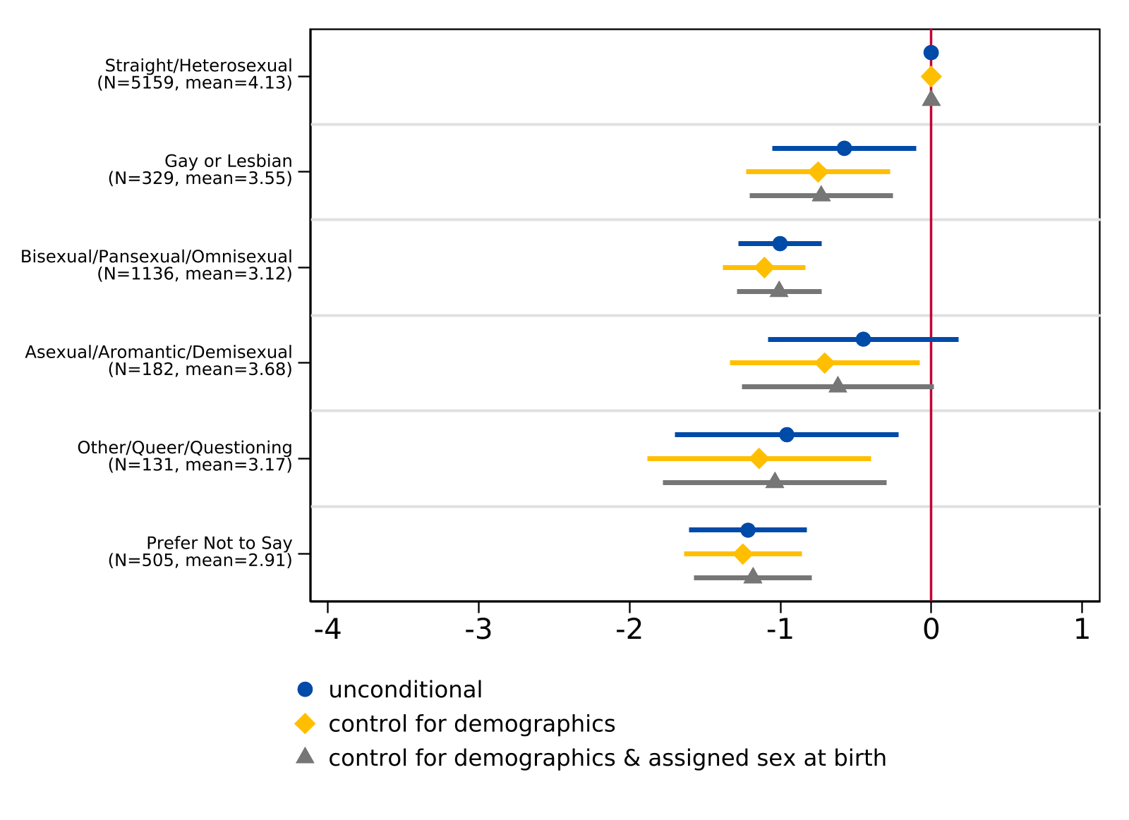
Note. For the unconditional model, n = 7,483. For the model controlling for demographics (race/ethnicity and parental level of education), n = 7,464. For the model controlling for demographics (race/ethnicity and parental level of education) and sex assigned at birth, n = 7,412. The lines indicate 95% confidence intervals while the sample frequency and mean index of each sexual orientation are reported in parentheses. The vertical line at 0 represents the coefficient for the reference group (straight/heterosexual).

Appendix G: College Worries by Sexual Orientation Robustness
Figure G1. Regression of Composite Index for General College Worries on Sexual Orientation
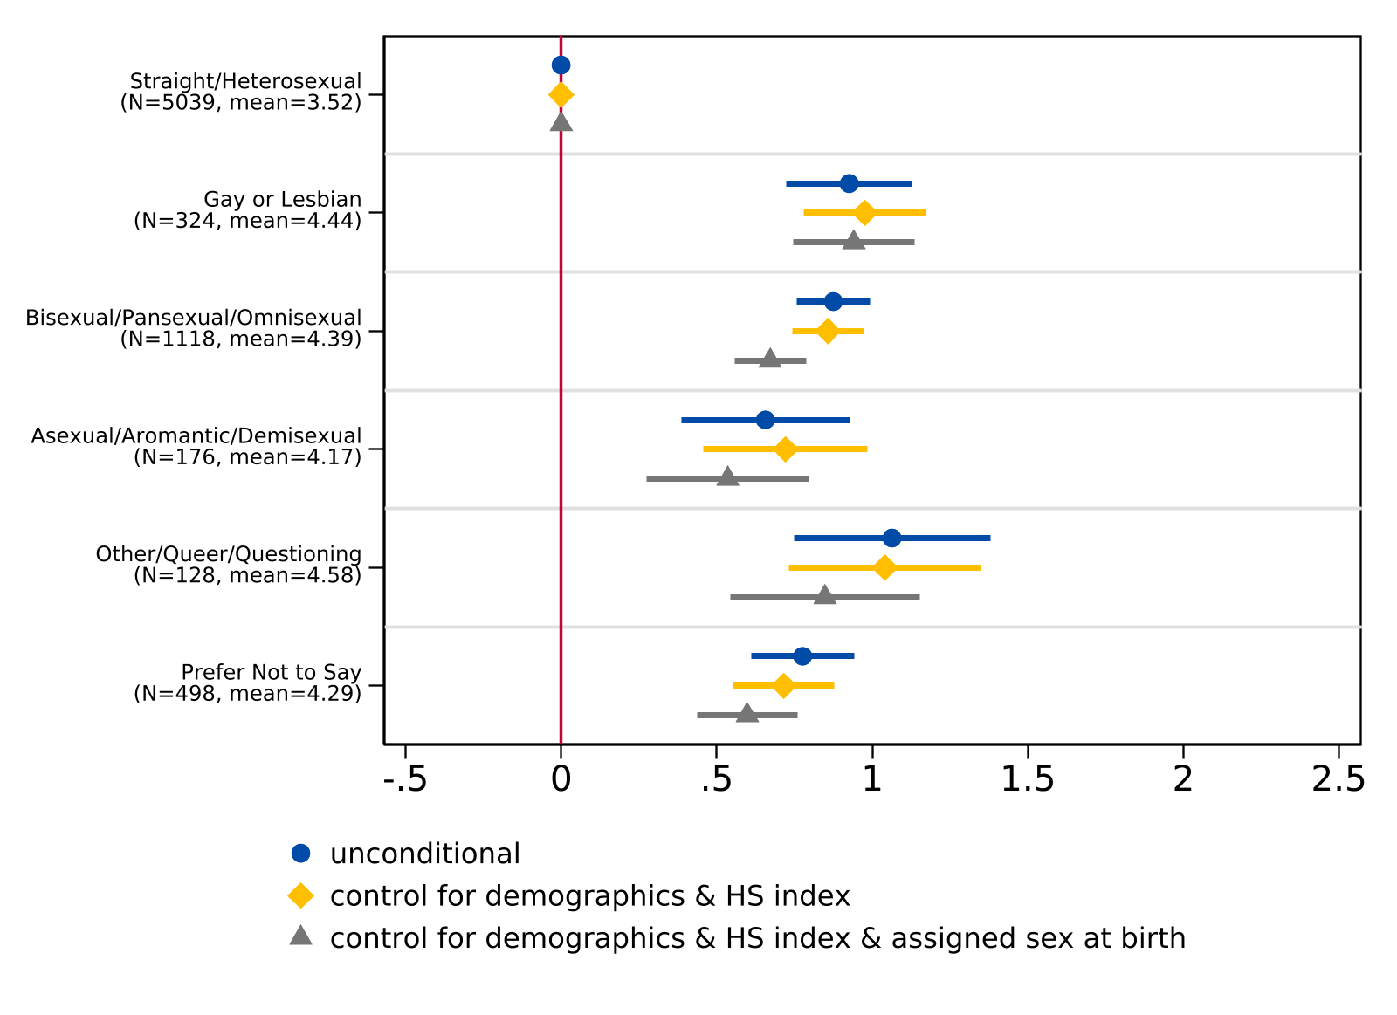
Note. For the unconditional model, n = 7,283. For the model controlling for demographics (race/ethnicity and parental level of education), n = 7,263. For the model controlling for demographics (race/ethnicity and parental level of education) and sex assigned at birth, n = 7,254. The lines indicate 95% confidence intervals while the sample frequency and mean index of each sexual orientation are reported in parentheses. The vertical line at 0 represents the coefficient for the reference group (straight/heterosexual).

Figure G2. Regression of Composite Index for College Worries about Discrimination on Sexual Orientation
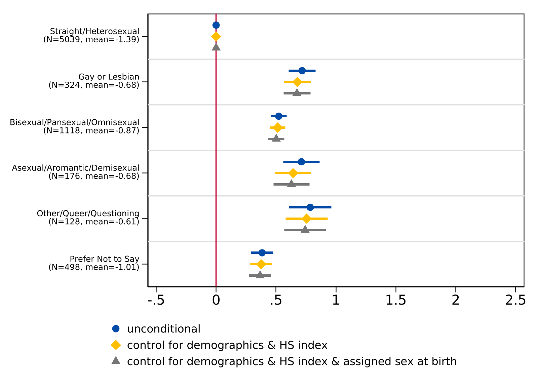
Note. For the unconditional model, n = 7,283. For the model controlling for demographics (race/ethnicity and parental level of education), n = 7,263. For the model controlling for demographics (race/ethnicity and parental level of education) and sex assigned at birth, n = 7,254. The lines indicate 95% confidence intervals while the sample frequency and mean index of each sexual orientation are reported in parentheses. The vertical line at 0 represents the coefficient for the reference group (straight/heterosexual).

Figure G3. Regression of Composite Index for College Worries about Financial Burdens on Sexual Orientation
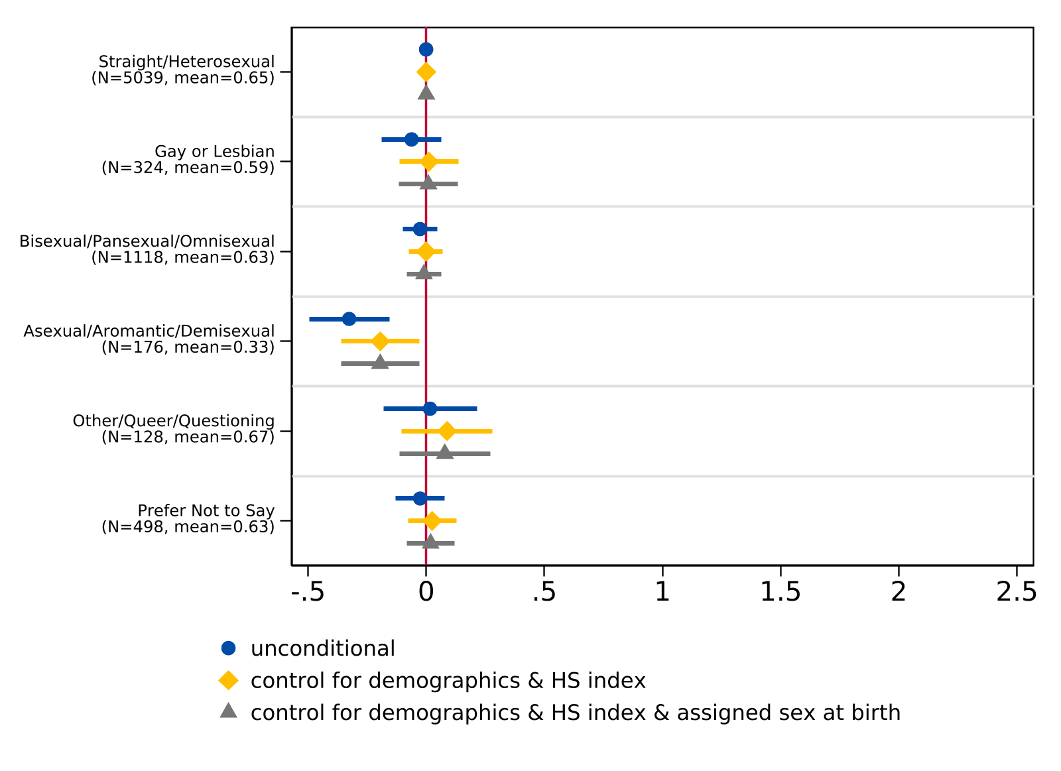
Note. For the unconditional model, n = 7,283. For the model controlling for demographics (race/ethnicity and parental level of education), n = 7,263. For the model controlling for demographics (race/ethnicity and parental level of education) and sex assigned at birth, n = 7,254. The lines indicate 95% confidence intervals while the sample frequency and mean index of each sexual orientation are reported in parentheses. The vertical line at 0 represents the coefficient for the reference group (straight/heterosexual).

Appendix H: Predicted Probabilities of Degree Aspirations
Figure H1. Predicted Probability of Degree Aspirations by Gender Identity, Evaluated at Sample Means
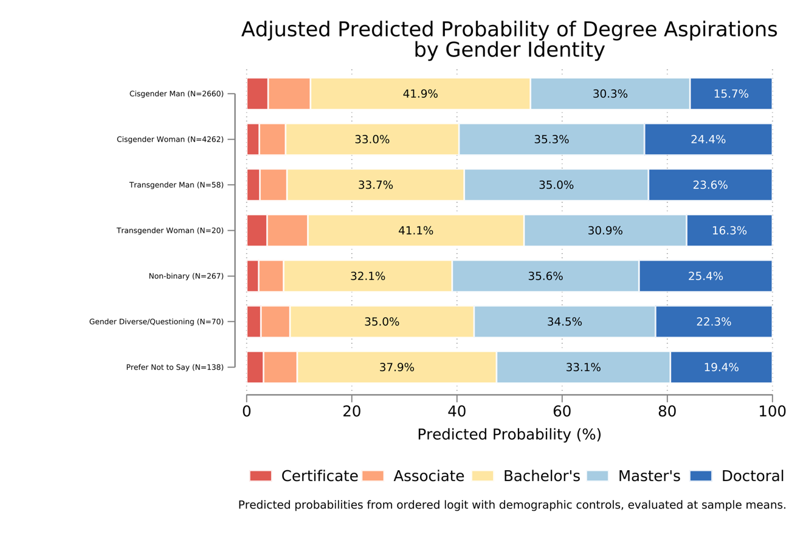
Note. Controlling for demographics (race/ethnicity and parent education).

Figure H2. Adjusted Predicted Probability of Degree Aspirations by Sexual Orientation, Evaluated at Sample Means
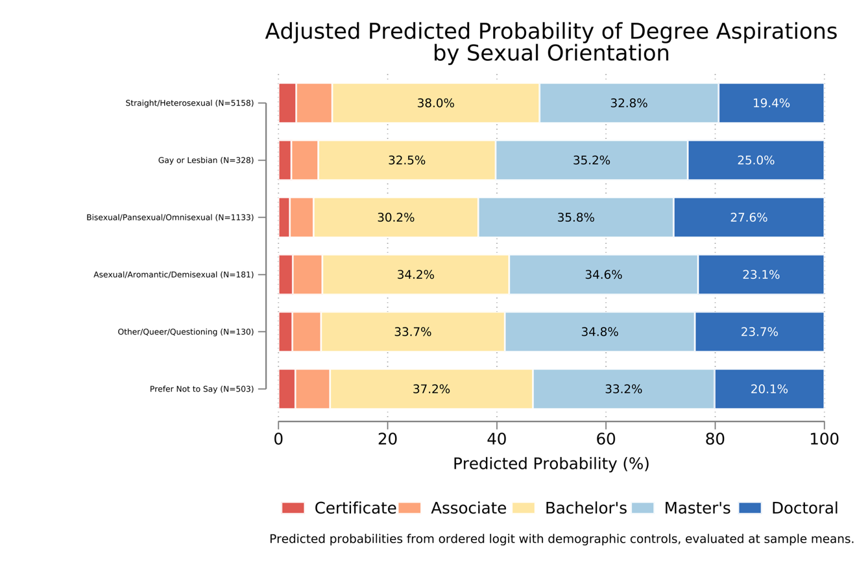
Note. Controlling for demographics (race/ethnicity and parent education).

Figure H3. Adjusted Predicted Probability of Degree Aspirations by Sexual Orientation, Evaluated at Sample Means, Controlling for Assigned Sex at Birth
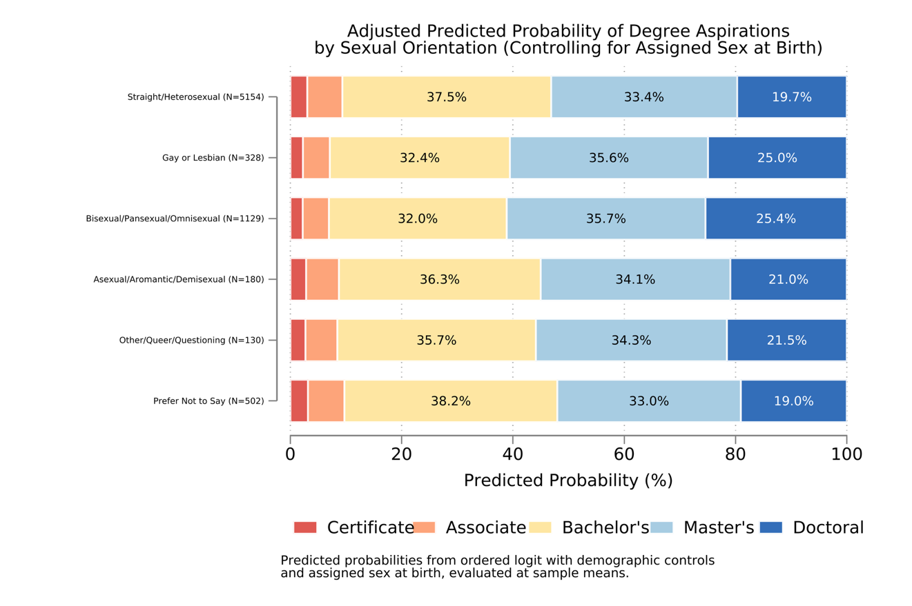
Note. Controlling for demographics (race/ethnicity and parent education) and assigned sex at birth.

Appendix I: Bullying as Mediator for High School Experience
Figure I1. Regression of High School Experience Index on Gender Identity, Controlling for Bullying
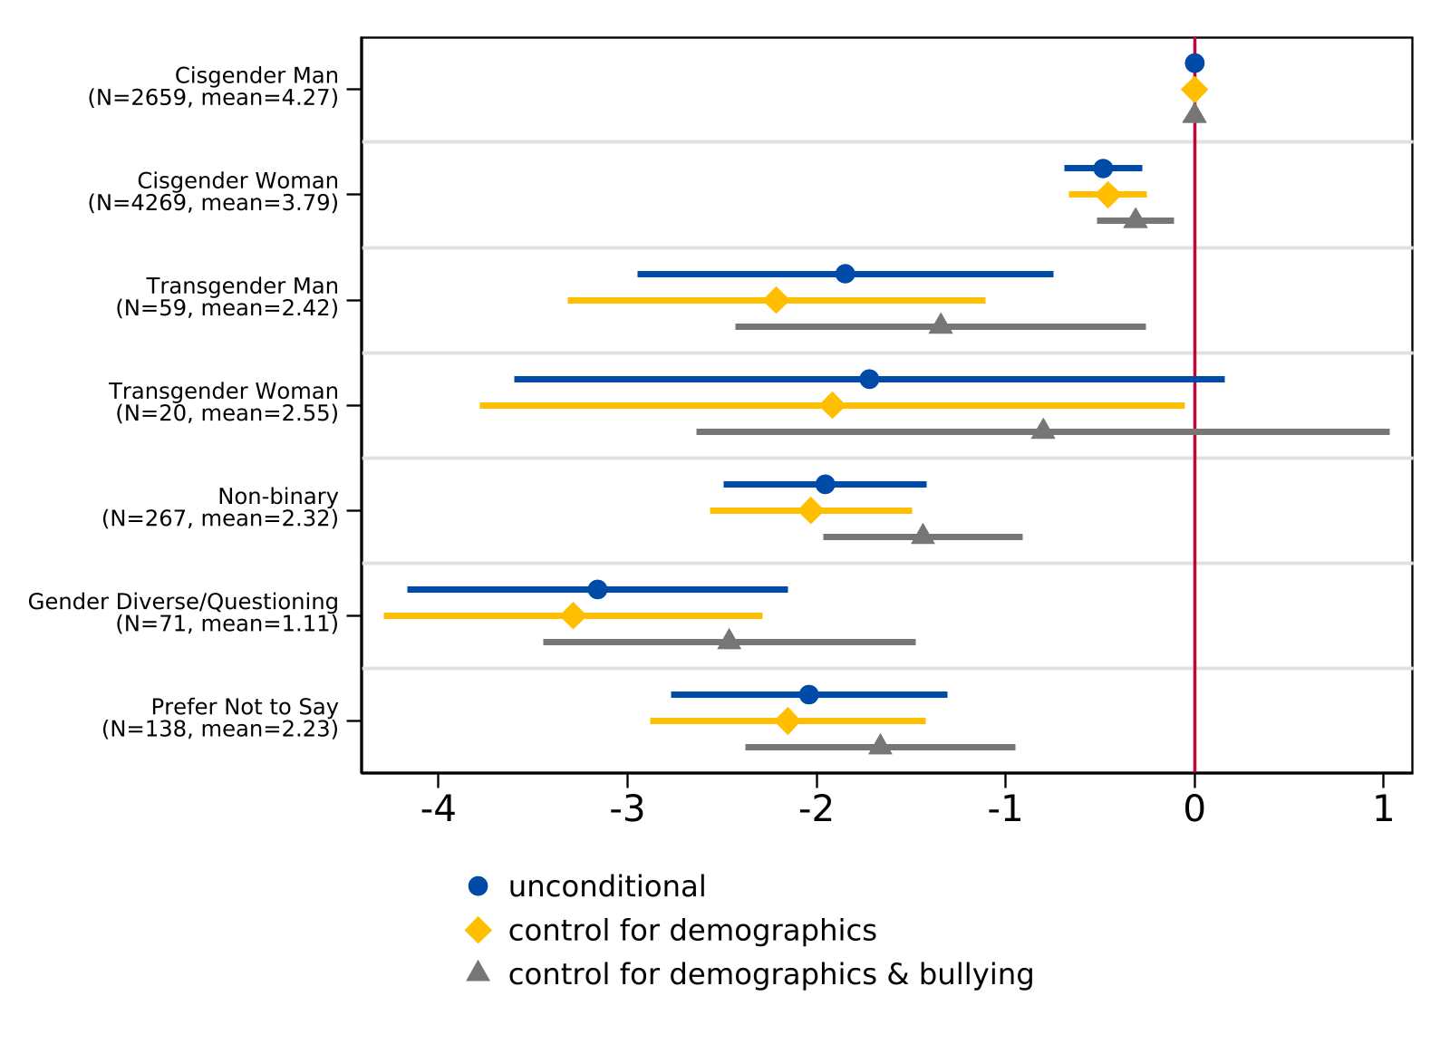
Note. For the unconditional model, n = 7,483. For the model controlling for demographics (race/ethnicity and parental level of education), n = 7,464. For the model controlling for demographics and frequency of bullying, n = 7,456. The lines indicate 95% confidence intervals while the sample frequency and mean index of each gender identity are reported in parentheses. The vertical line at 0 represents the coefficient for the reference group (cisgender man).

Figure I2. Regression of High School Experience Index on Sexual Orientation, Controlling for Bullying
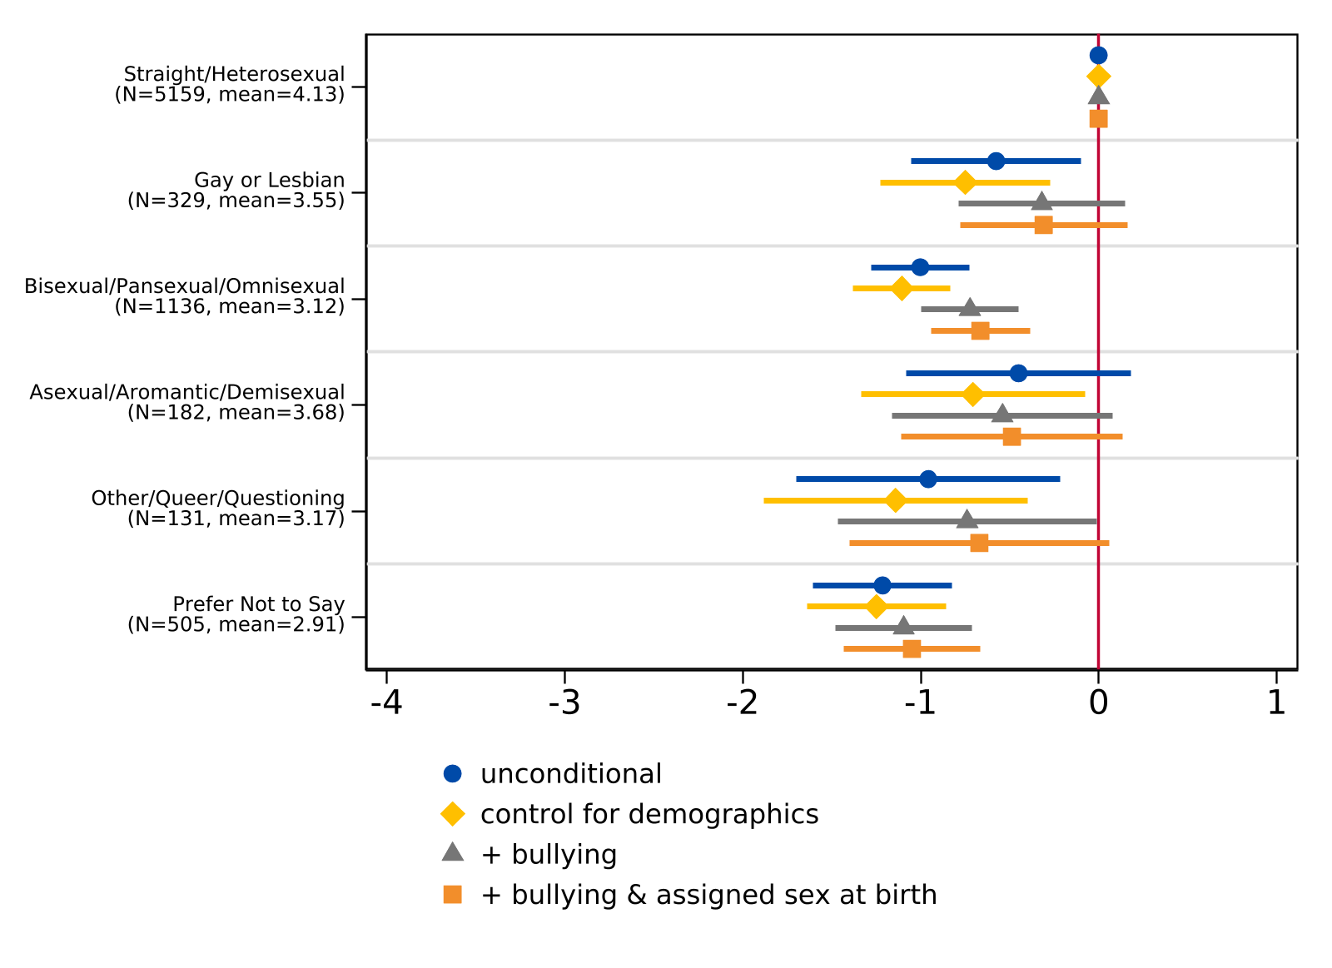
Note. For the unconditional model, n = 7,442. For the model controlling for demographics (race/ethnicity and parental level of education), n = 7,422. For the model controlling for demographics and frequency of bullying, n = 7,414. For the model additionally controlling for assigned sex at birth, n = 7,404. The lines indicate 95% confidence intervals while the sample frequency and mean index of each sexual orientation are reported in parentheses. The vertical line at 0 represents the coefficient for the reference group (straight/heterosexual).

Appendix J: Bullying as Mediator for College Worries

Figure J1. Regression of Composite Index of General College Worries on Gender Identity, Controlling for Bullying
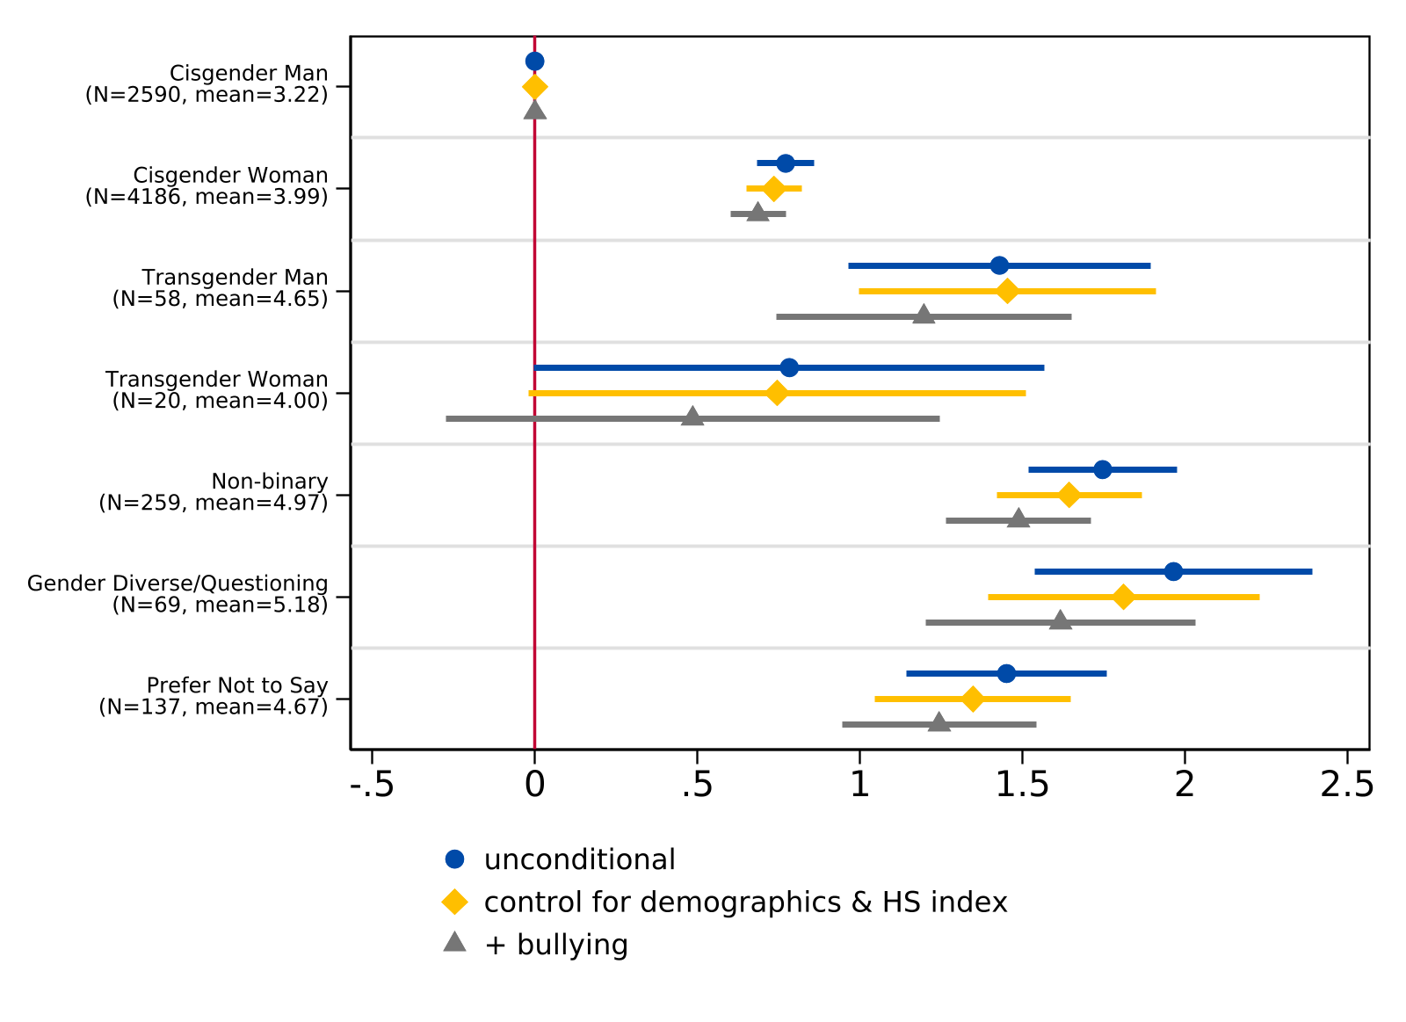
Note. For the unconditional model, n = 7,319. For the model controlling for demographics (race/ethnicity and parental level of education) and the high school experience index, n = 7,276. For the model additionally controlling for frequency of bullying, n = 7,269. The lines indicate 95% confidence intervals while the sample frequency and mean index of each gender identity are reported in parentheses. The vertical line at 0 represents the coefficient for the reference group (cisgender man).

Figure J2. Regression of Composite Index of General College Worries on Sexual Orientation, Controlling for Bullying
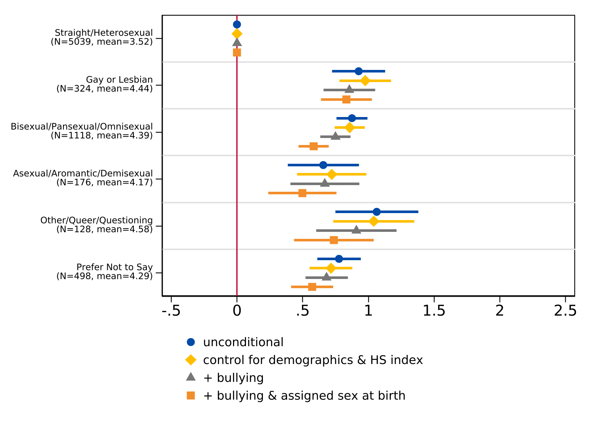
Note. For the unconditional model, n = 7,283. For the model controlling for demographics (race/ethnicity and parental level of education) and the high school experience index, n = 7,239. For the model additionally controlling for frequency of bullying, n = 7,232. For the model additionally controlling for assigned sex at birth, n = 7,223. The lines indicate 95% confidence intervals while the sample frequency and mean index of each sexual orientation are reported in parentheses. The vertical line at 0 represents the coefficient for the reference group (straight/heterosexual).

Figure J3. Regression of Composite Index of College Worries about Discrimination on Gender Identity, Controlling for Bullying
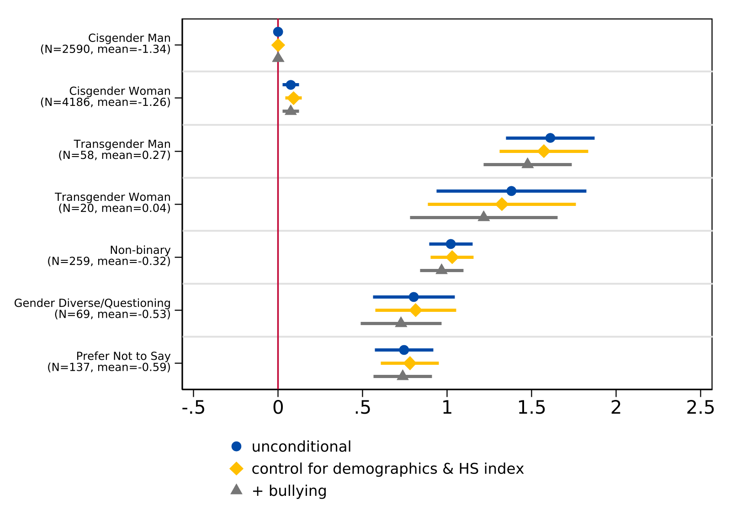
Note. For the unconditional model, n = 7,319. For the model controlling for demographics (race/ethnicity and parental level of education) and the high school experience index, n = 7,276. For the model additionally controlling for frequency of bullying, n = 7,269. The lines indicate 95% confidence intervals while the sample frequency and mean index of each gender identity are reported in parentheses. The vertical line at 0 represents the coefficient for the reference group (cisgender man).

Figure J4. Regression of Composite Index of College Worries about Discrimination on Sexual Orientation, Controlling for Bullying
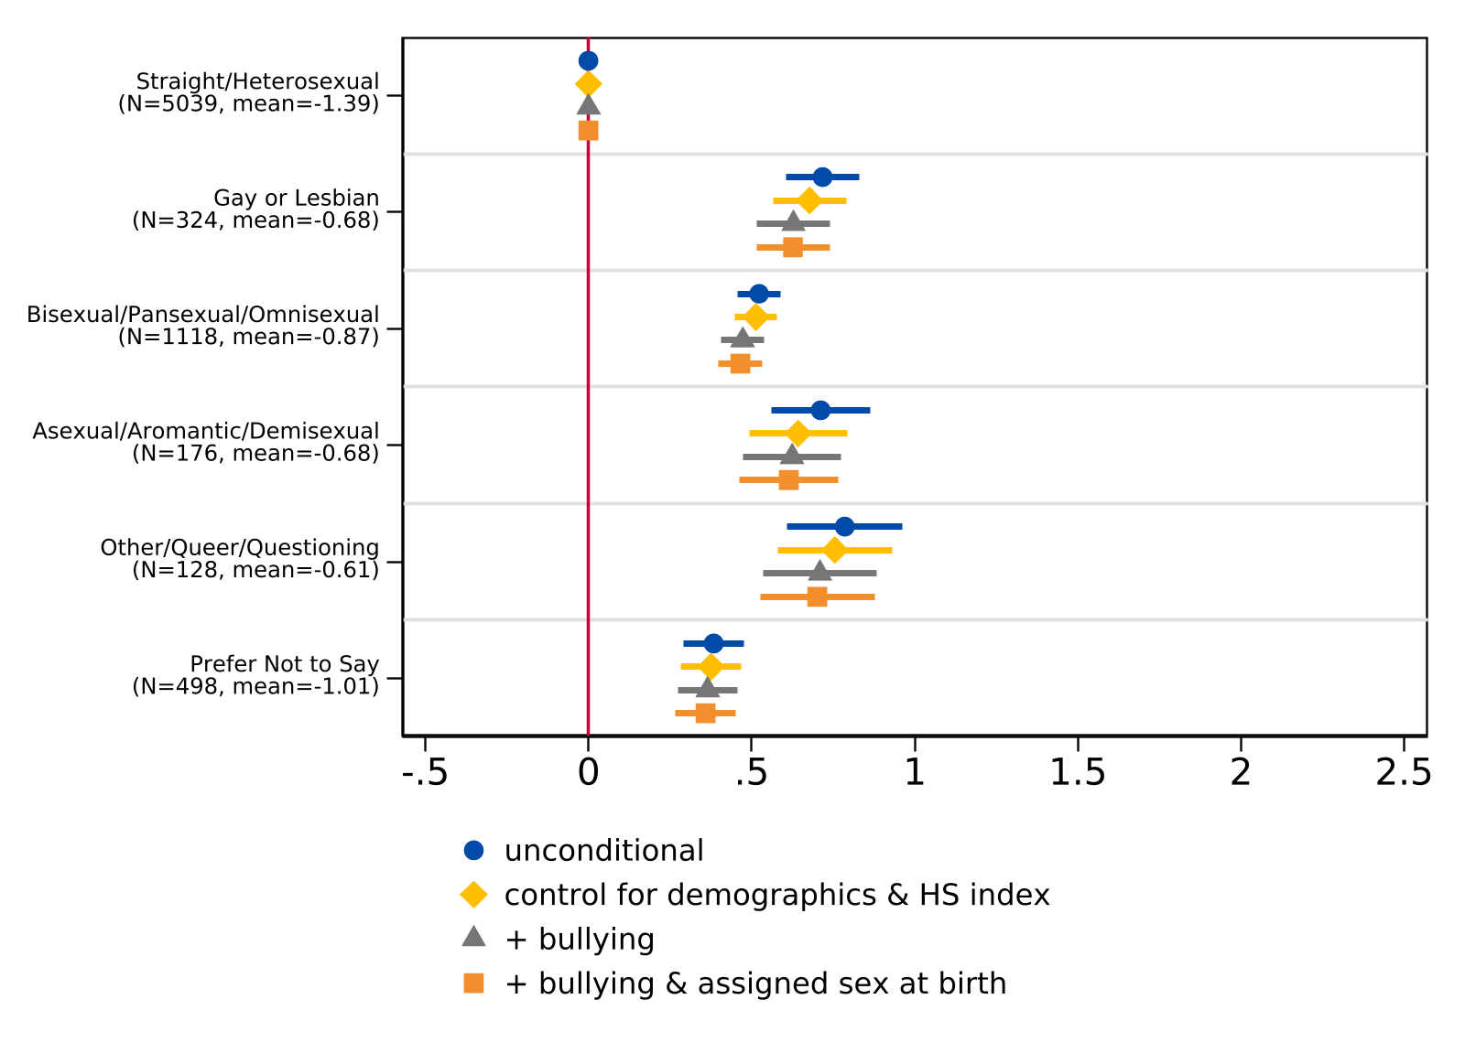
Note. For the unconditional model, n = 7,283. For the model controlling for demographics (race/ethnicity and parental level of education) and the high school experience index, n = 7,239. For the model additionally controlling for frequency of bullying, n = 7,232. For the model additionally controlling for assigned sex at birth, n = 7,223. The lines indicate 95% confidence intervals while the sample frequency and mean index of each sexual orientation are reported in parentheses. The vertical line at 0 represents the coefficient for the reference group (straight/heterosexual).

Figure J5. Regression of Composite Index of College Worries about Financial Burdens on Gender Identity, Controlling for Bullying
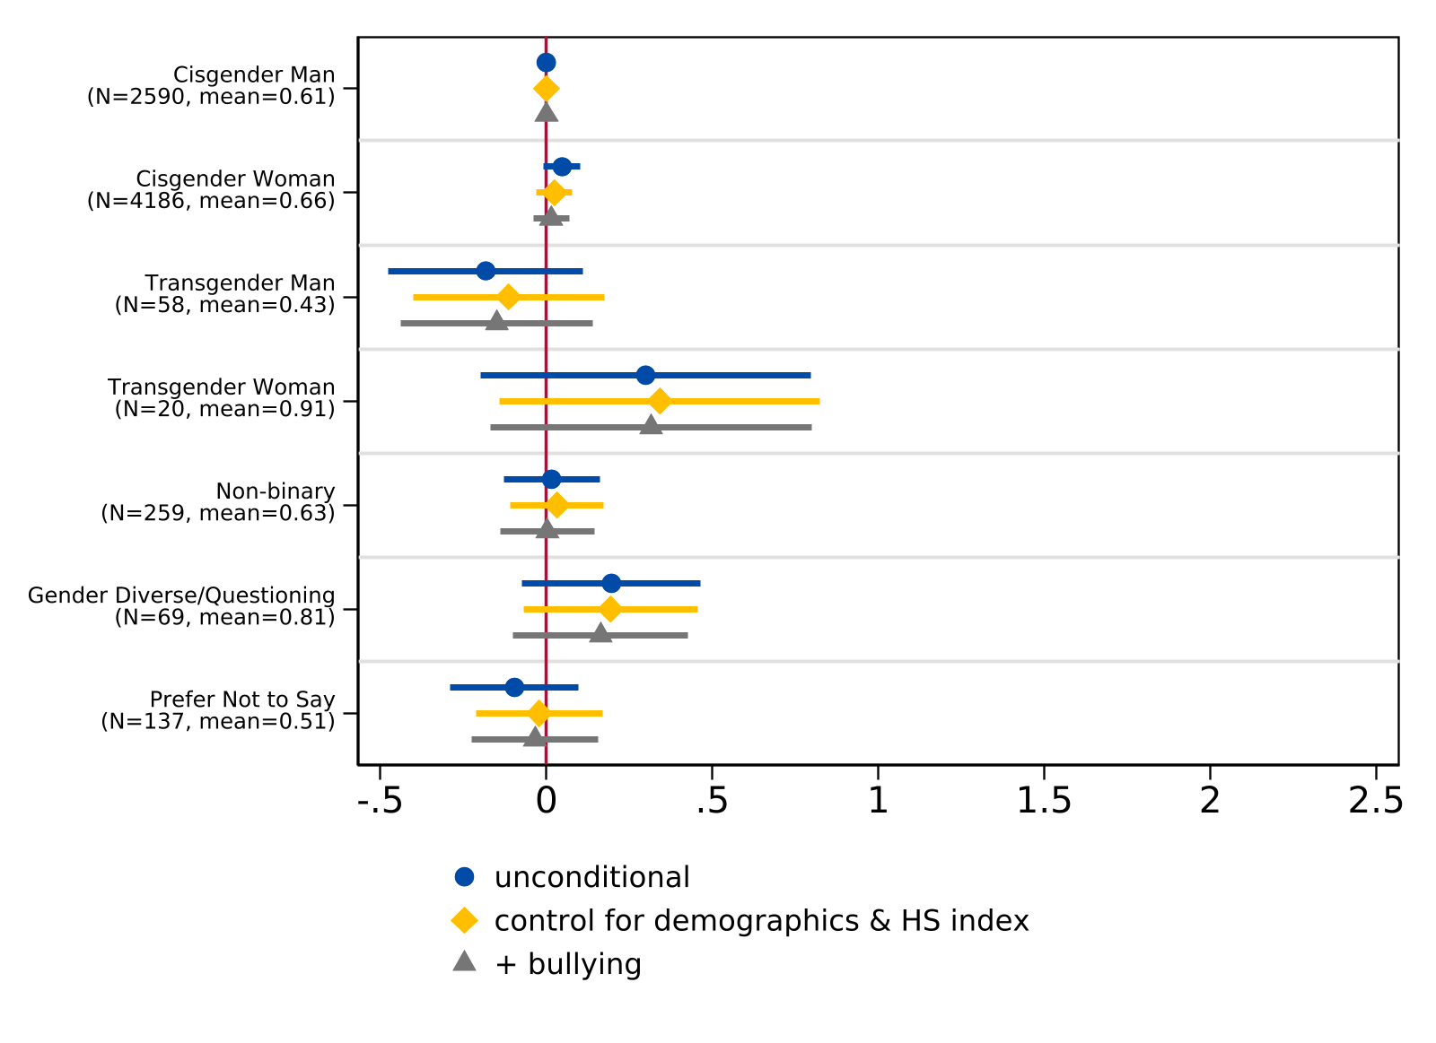
Note. For the unconditional model, n = 7,319. For the model controlling for demographics (race/ethnicity and parental level of education) and the high school experience index, n = 7,276. For the model additionally controlling for frequency of bullying, n = 7,269. The lines indicate 95% confidence intervals while the sample frequency and mean index of each gender identity are reported in parentheses. The vertical line at 0 represents the coefficient for the reference group (cisgender man).

Figure J6. Regression of Composite Index of College Worries about Financial Burdens on Sexual Orientation, Controlling for Bullying
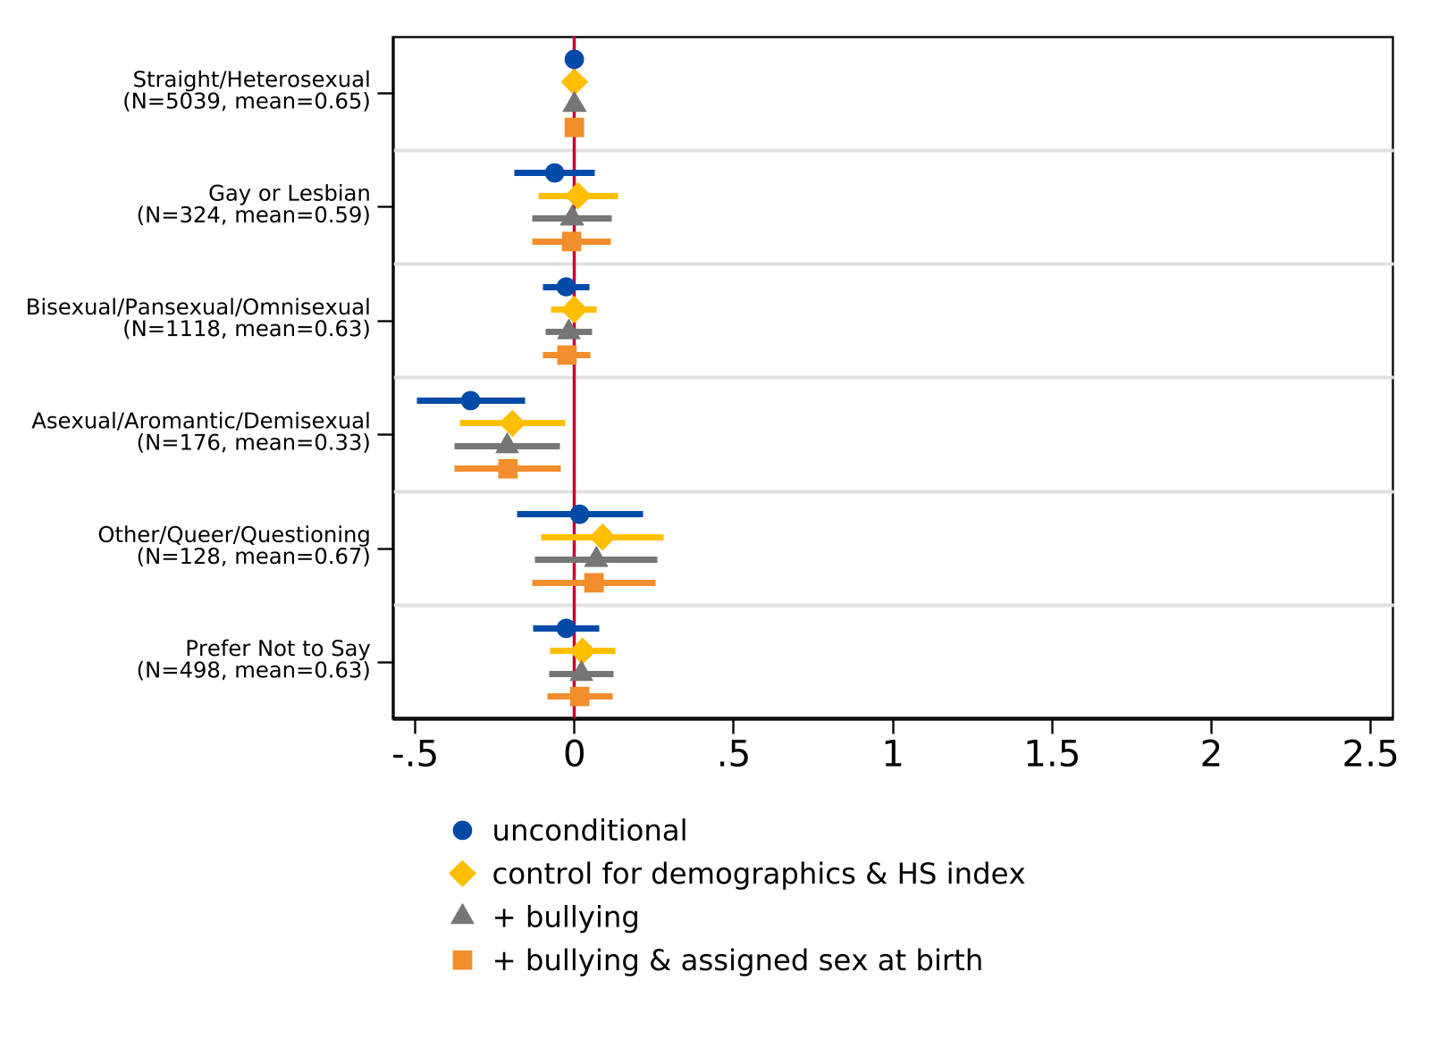
Note. For the unconditional model, n = 7,283. For the model controlling for demographics (race/ethnicity and parental level of education) and the high school experience index, n = 7,239. For the model additionally controlling for frequency of bullying, n = 7,232. For the model additionally controlling for assigned sex at birth, n = 7,223. The lines indicate 95% confidence intervals while the sample frequency and mean index of each sexual orientation are reported in parentheses. The vertical line at 0 represents the coefficient for the reference group (straight/heterosexual).

This research was approved by the Institutional Review Board (IRB) at the University of California, Davis under protocol number 2041454-1 and considered minimal risk. Informed consent was obtained from all participants prior to survey administration.
Of the 266 students who identified as nonbinary, 87% (n = 231) were assigned female at birth.
In the survey sample, of all students who responded to the gender identity questions (N = 7,551), 1.1% (n = 86) selected “other” and wrote in a response.
A full descriptive examination of the diverse labels students used to describe their gender identities and sexual orientation in the open response option, beyond those provided, is included in a companion paper currently under review (Hurtt et al., 2026, forthcoming).
In the survey sample, of all students who responded to the sexual orientation questions (N = 7,507), 3.1% (n = 231) selected “other” and wrote in a response.
Detailed information about the qualitative methods and additional results is included in a companion paper currently under review (Hurtt et al., 2026, forthcoming). Summary statistics of the qualitative sample can be found in Appendix E.
See Appendix B for high school experience survey items and summary statistics.
For sexual orientation, we also estimate an additional specification that controls for assigned sex at birth. See Appendix F for results.
PCA is a statistical technique that reduces the dimensionality of complex data by identifying underlying patterns and grouping correlated variables into distinct components/constructs. This approach is particularly useful when analyzing multiple survey items that may measure overlapping concepts as it allows us to identify the core dimensions of students’ concerns while reducing dimensionality in the data.
For more information about the California Healthy Kids Survey, see https://www.cde.ca.gov/ls/he/at/chks.asp and https://calschls.org/about/the-surveys.

